**CMPE 264 – Project Assignment 2**

**Project report**

**Yifan Xu, Chenjie Zhou**

**Part1: Camera Calibration**

The camera we used for this project is ipone7. (We’ve locked the room at a certain level)

We used camera of iPhone 7 for this part and use Camera+ to lock the focus. For chessboard, we downloaded it in iPad and take 15 pictures from different views. Finally, we calibrated our camera by using cameraCalibrator in Matlab.

In cameraCalibrator, it generated world coordinates of the corners of the squares (the square size we choose is 21.3mm. Then We used estimateCameraParameters to compute the intrinsic matrix and radial distortion coefficients. The function can show us the view reprojection errors and visualized the pattern locations. And displayed parameter estimation errors.

The chessboard we took:

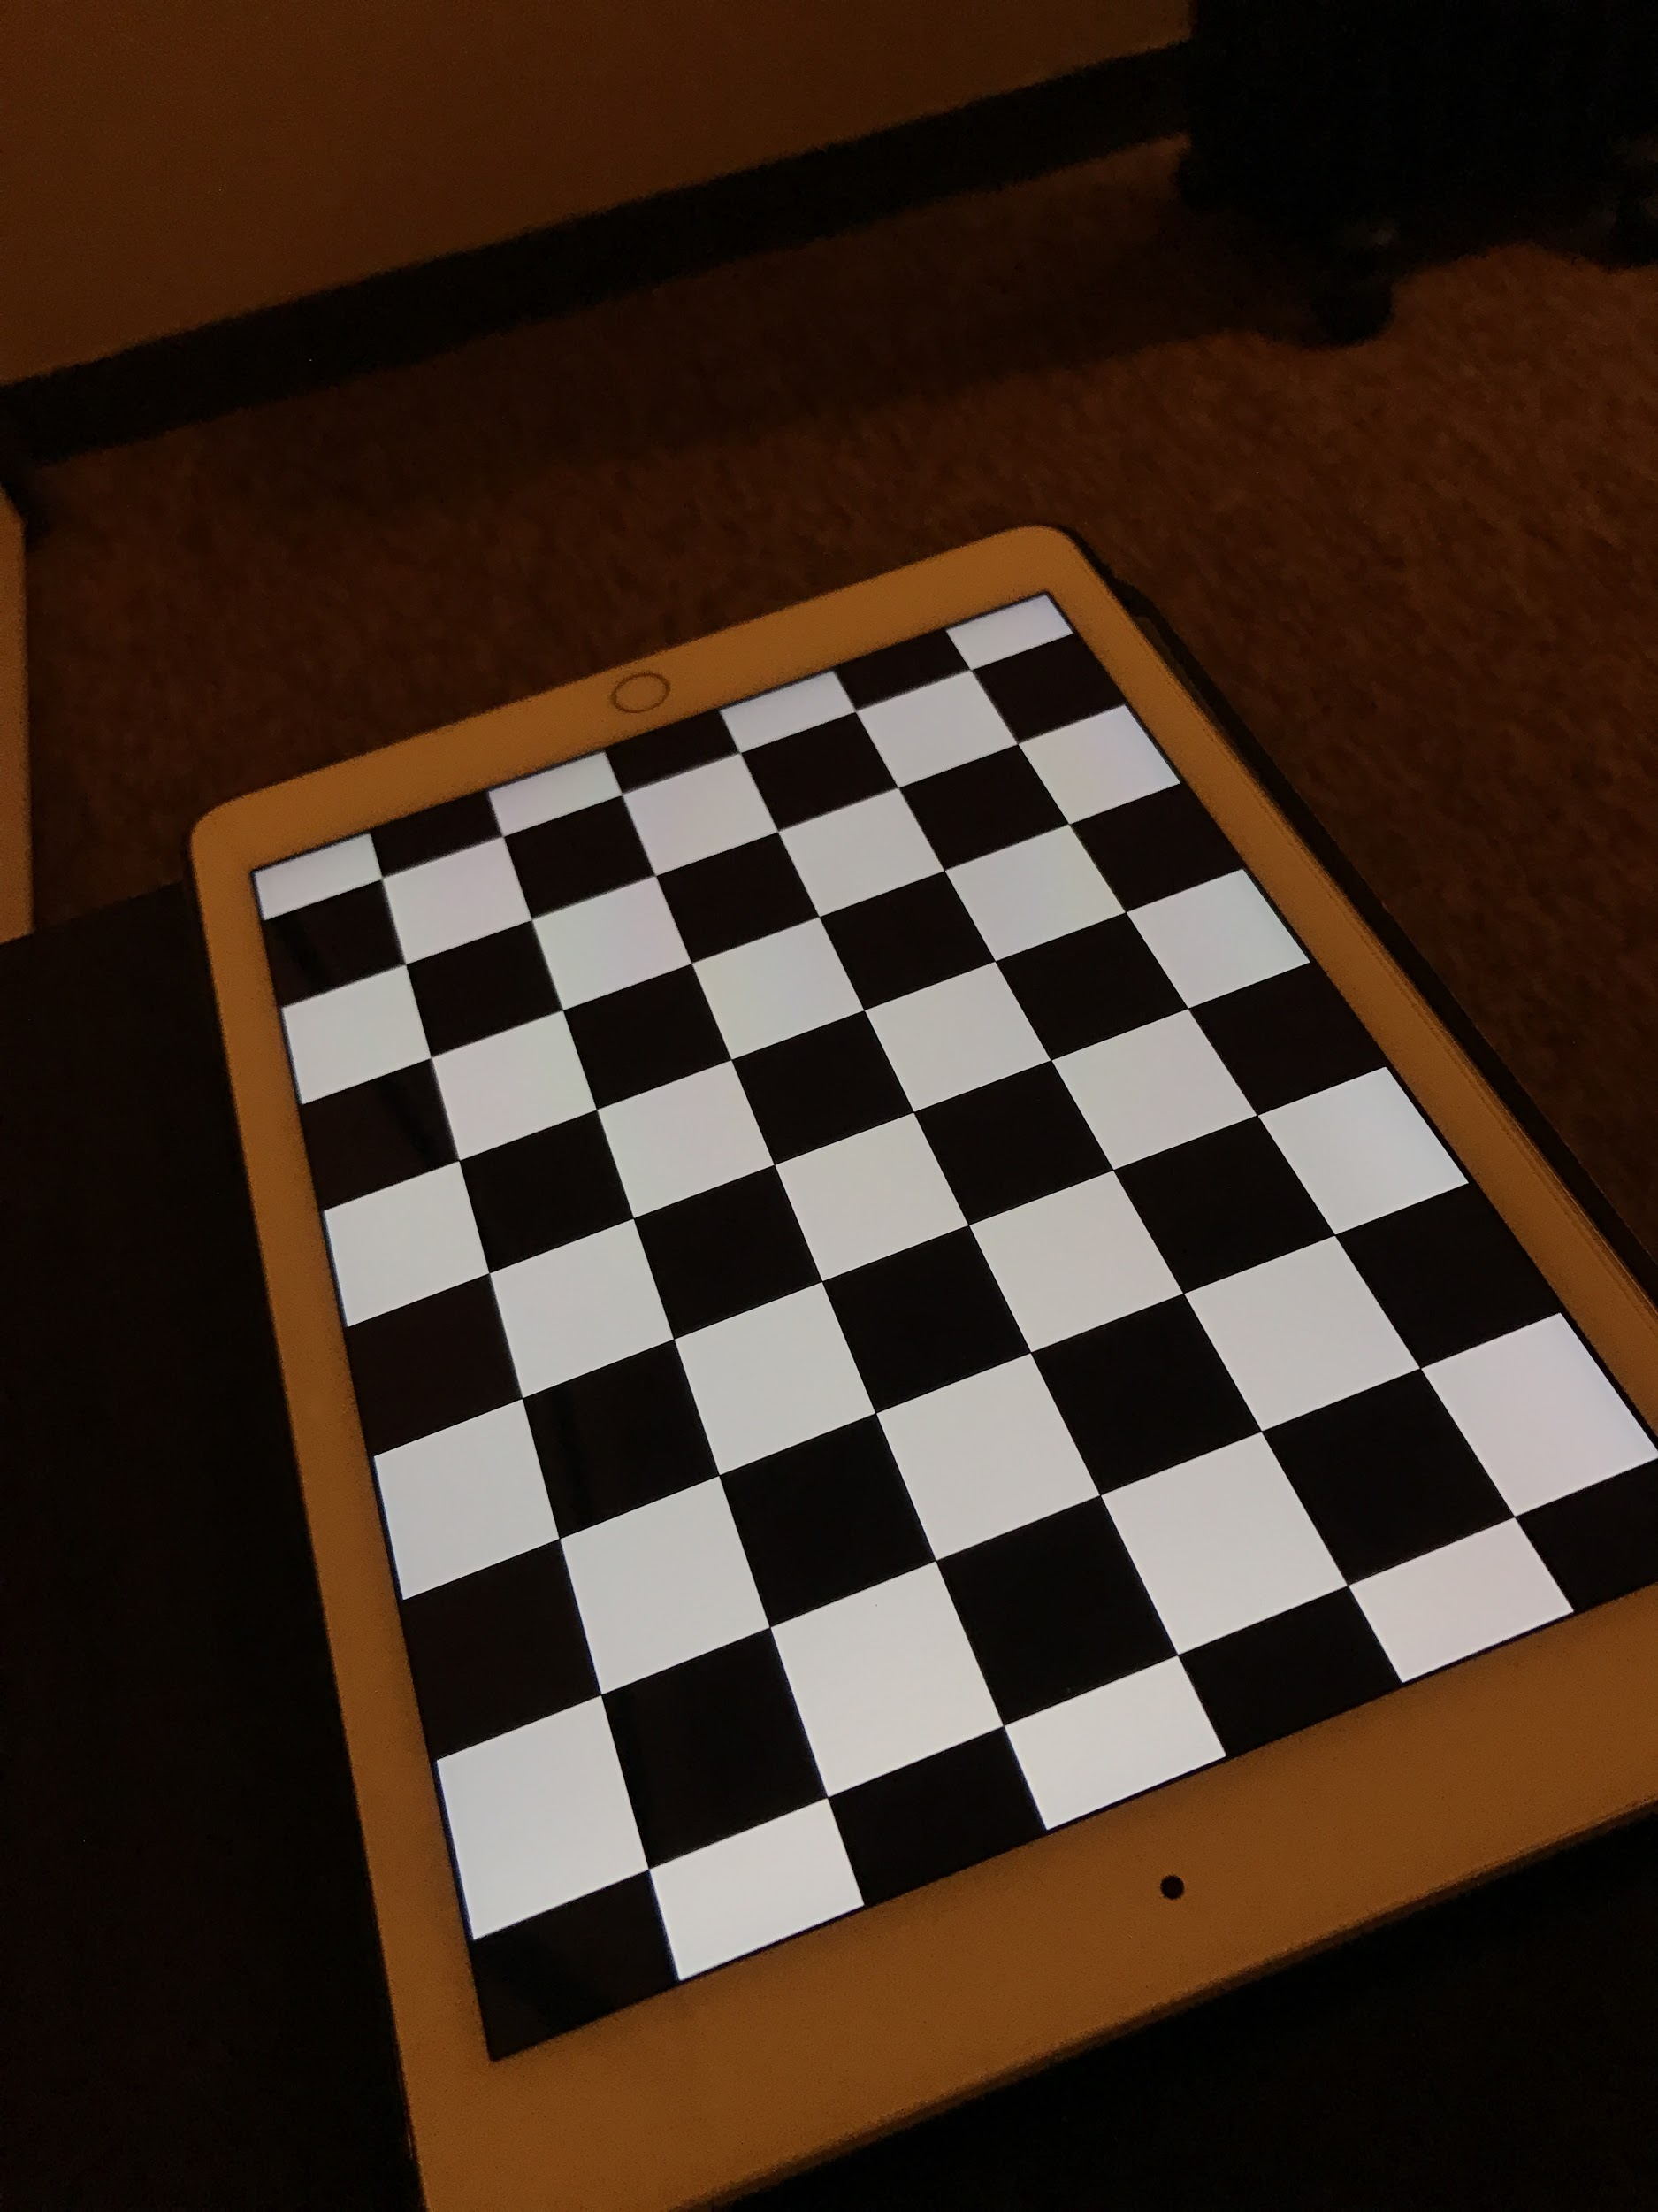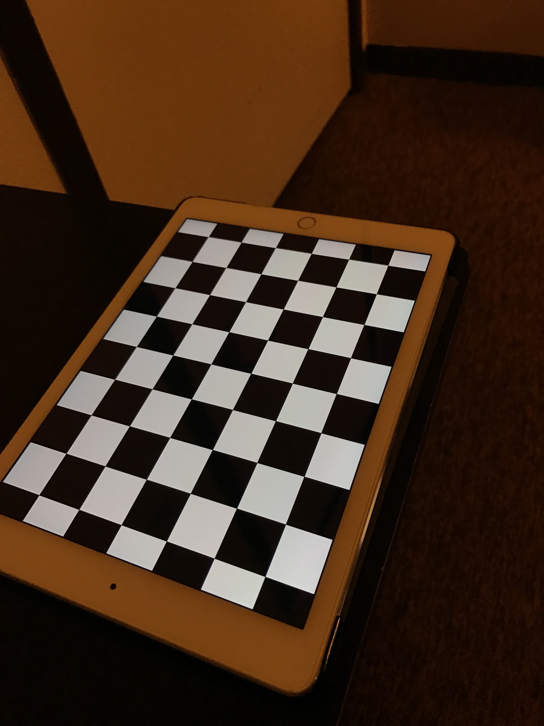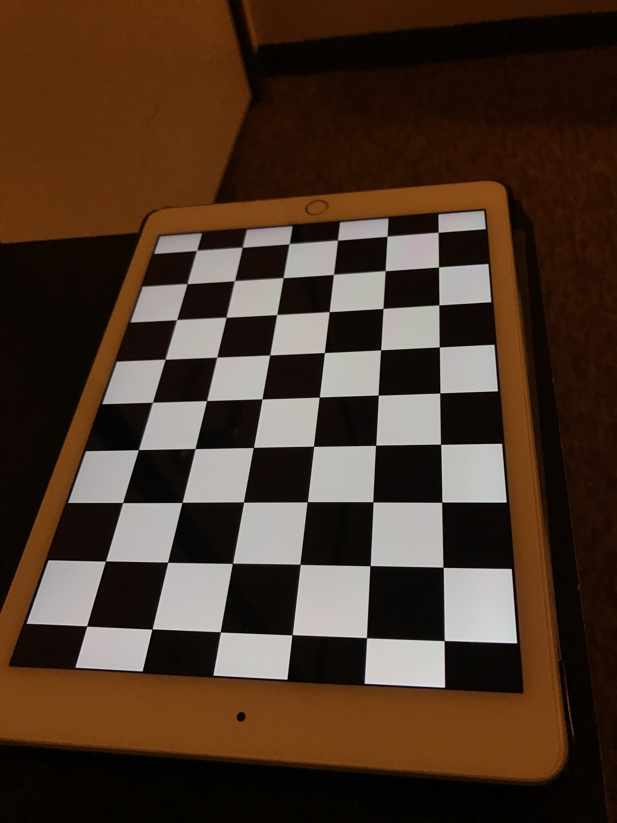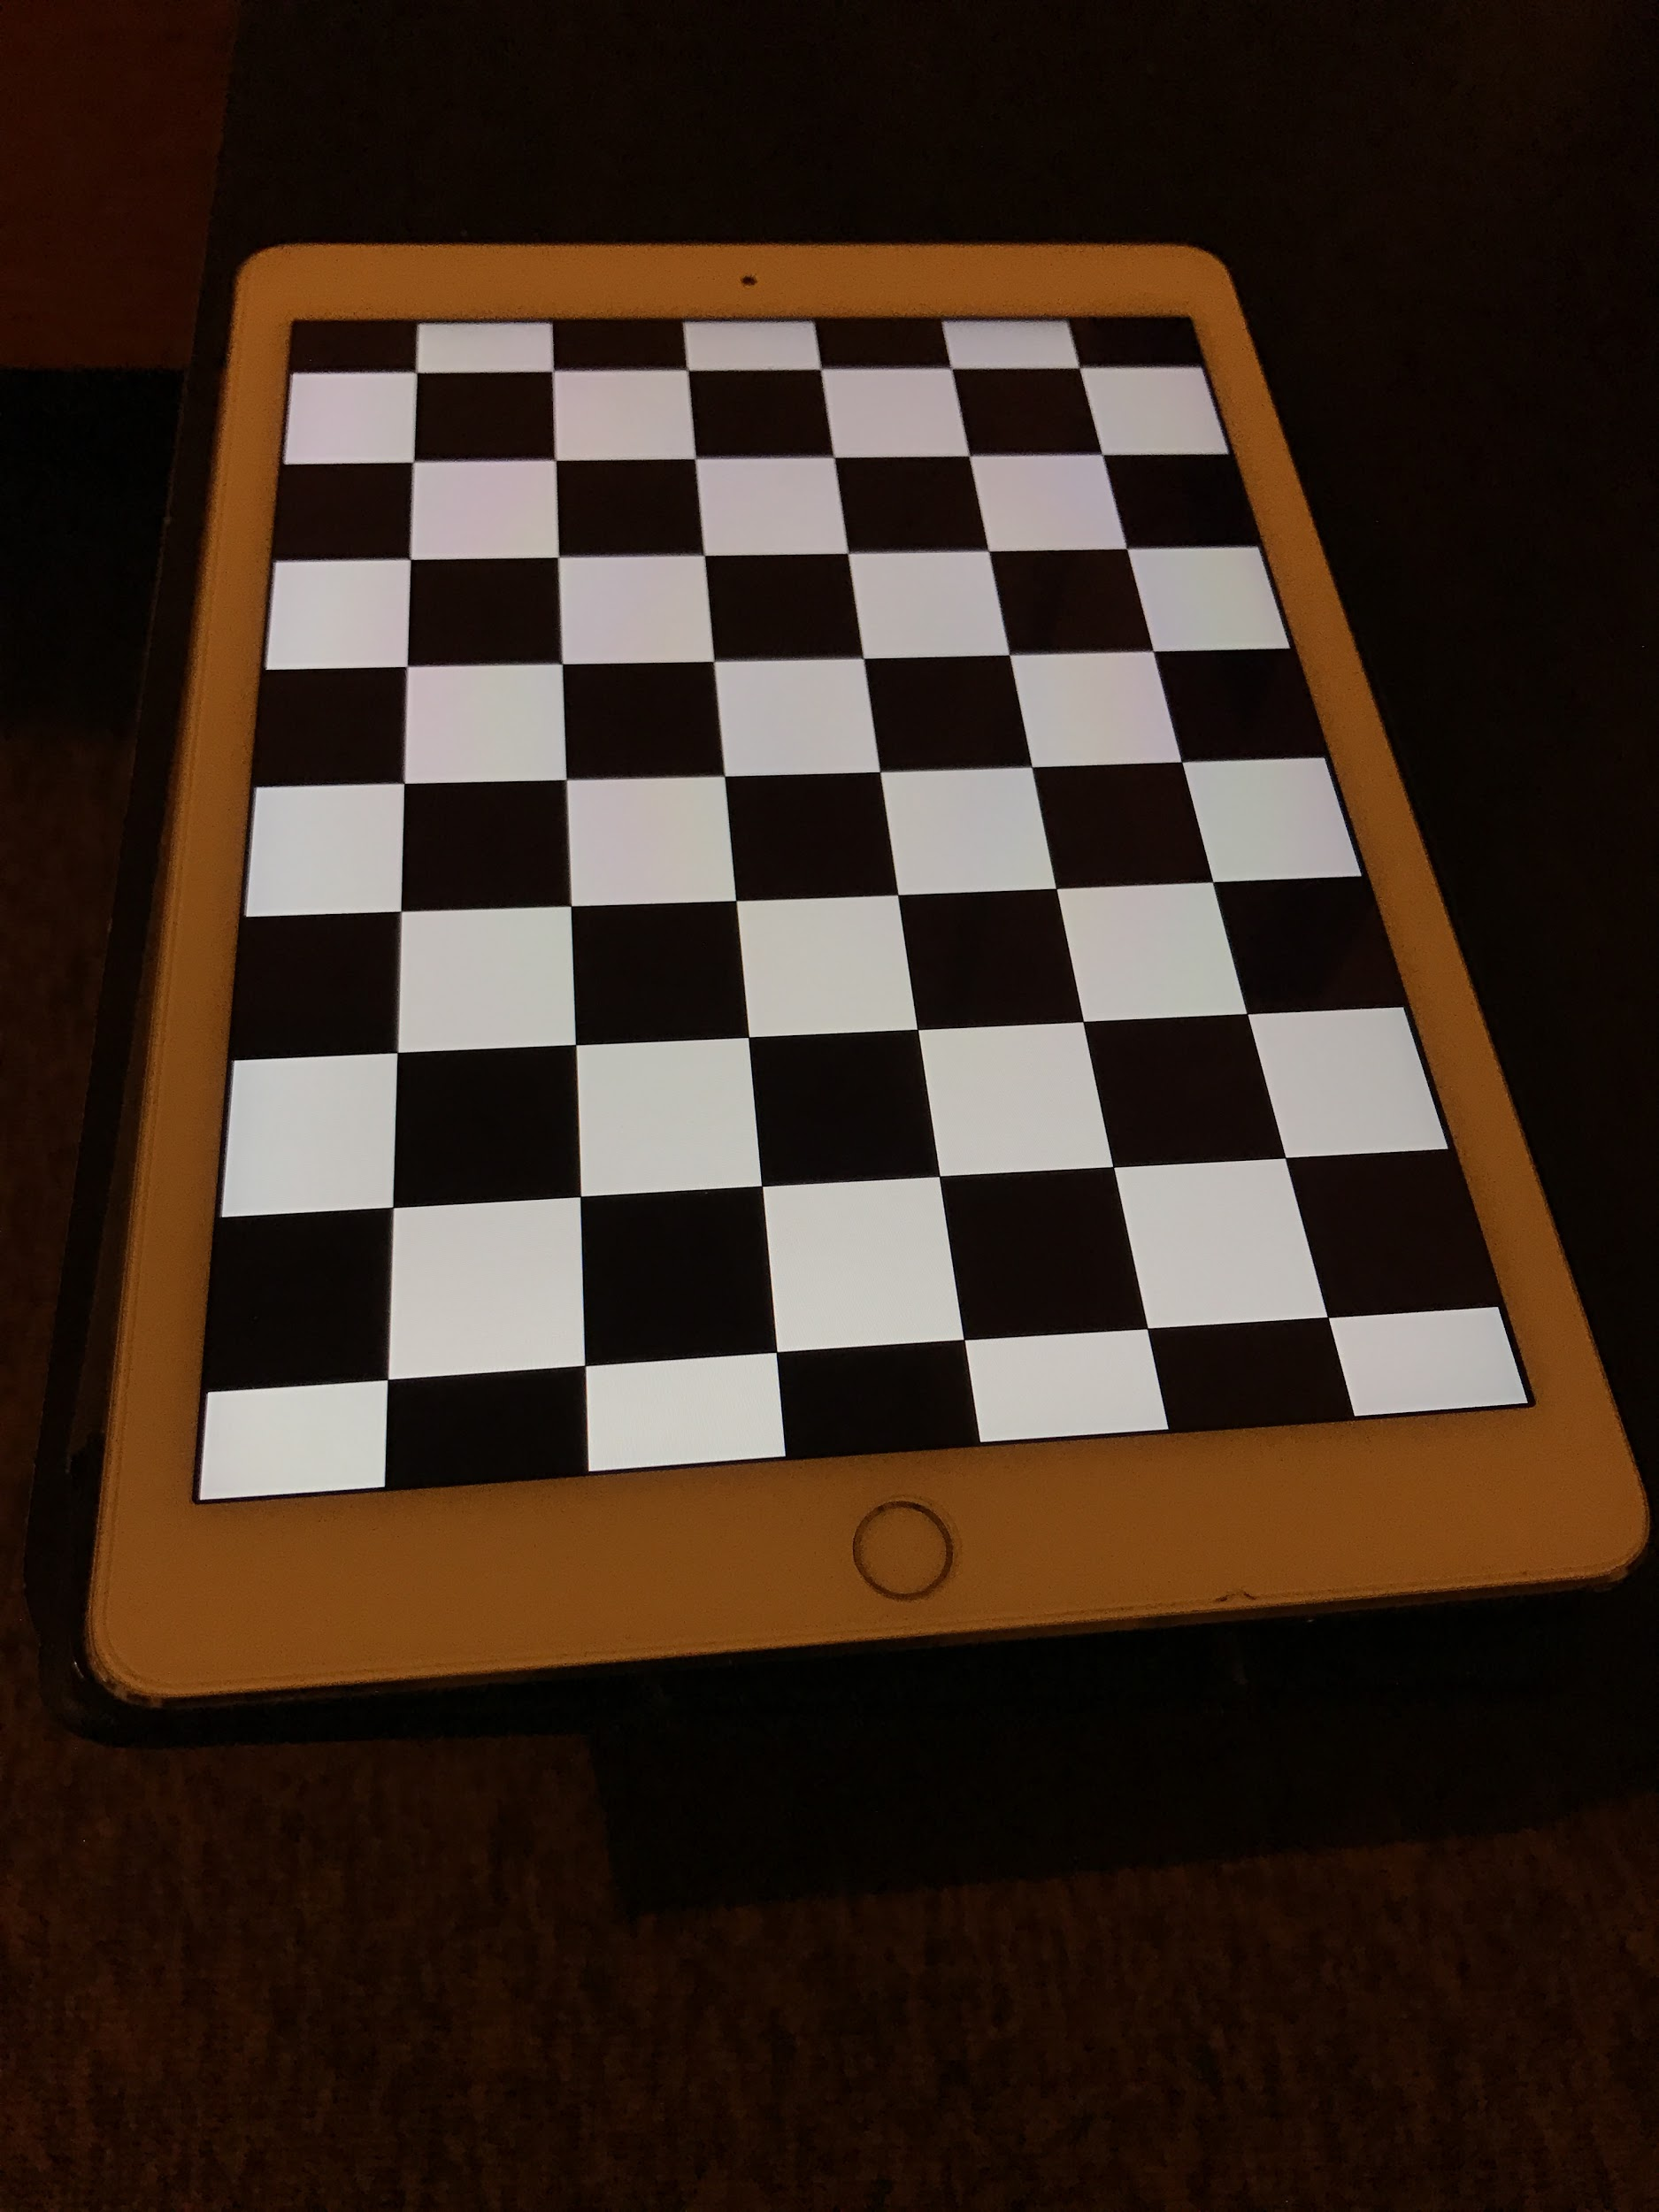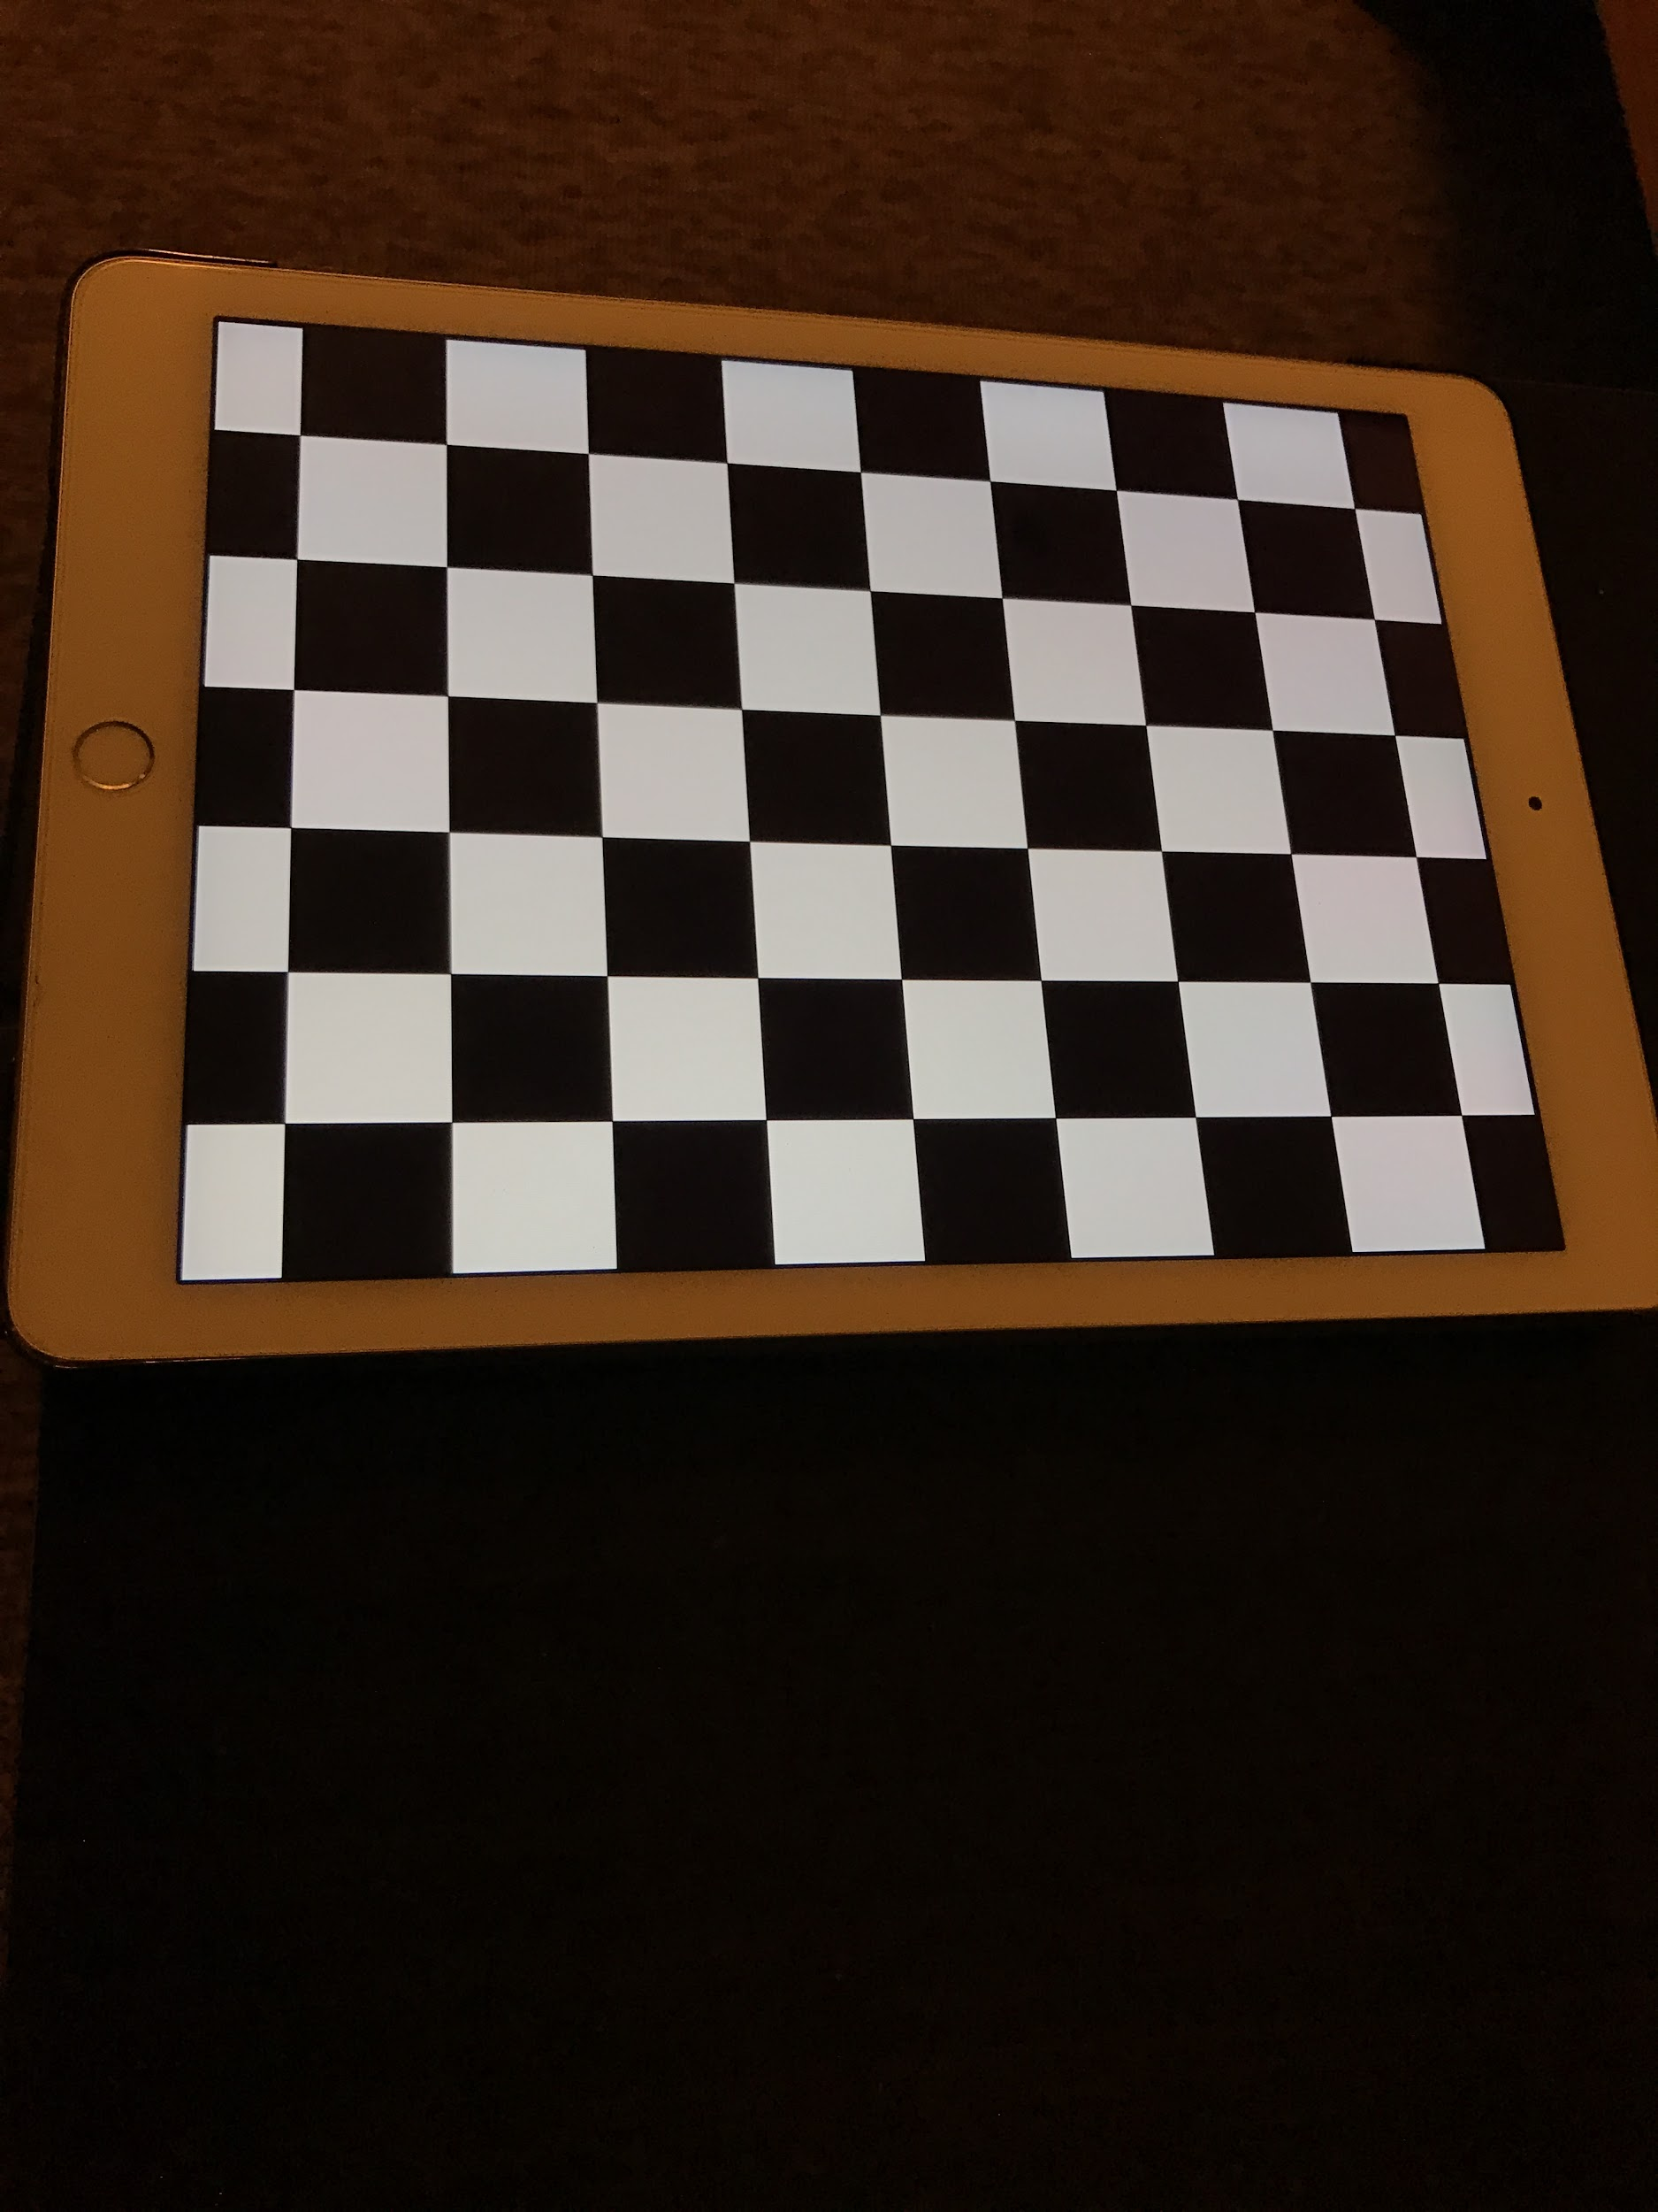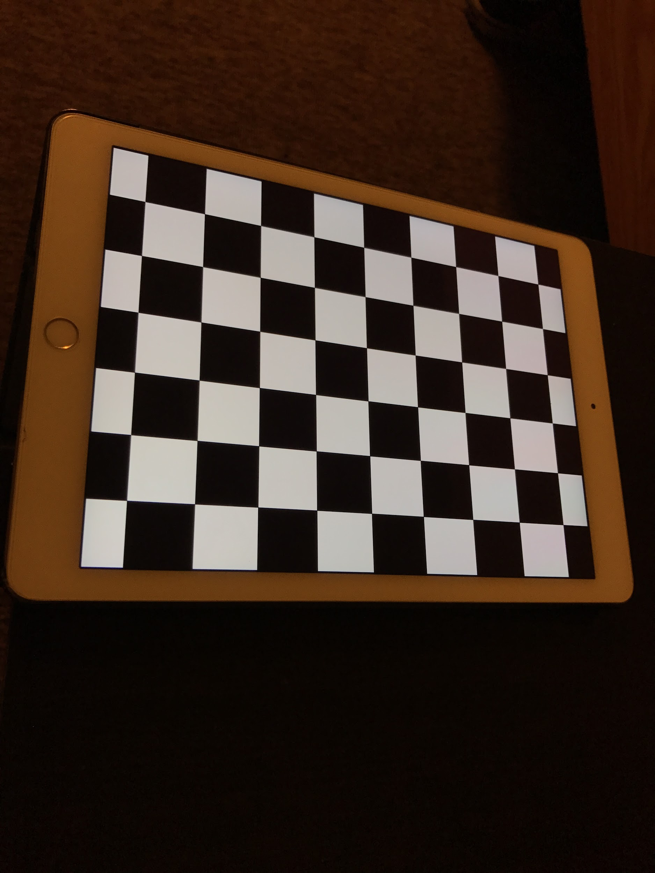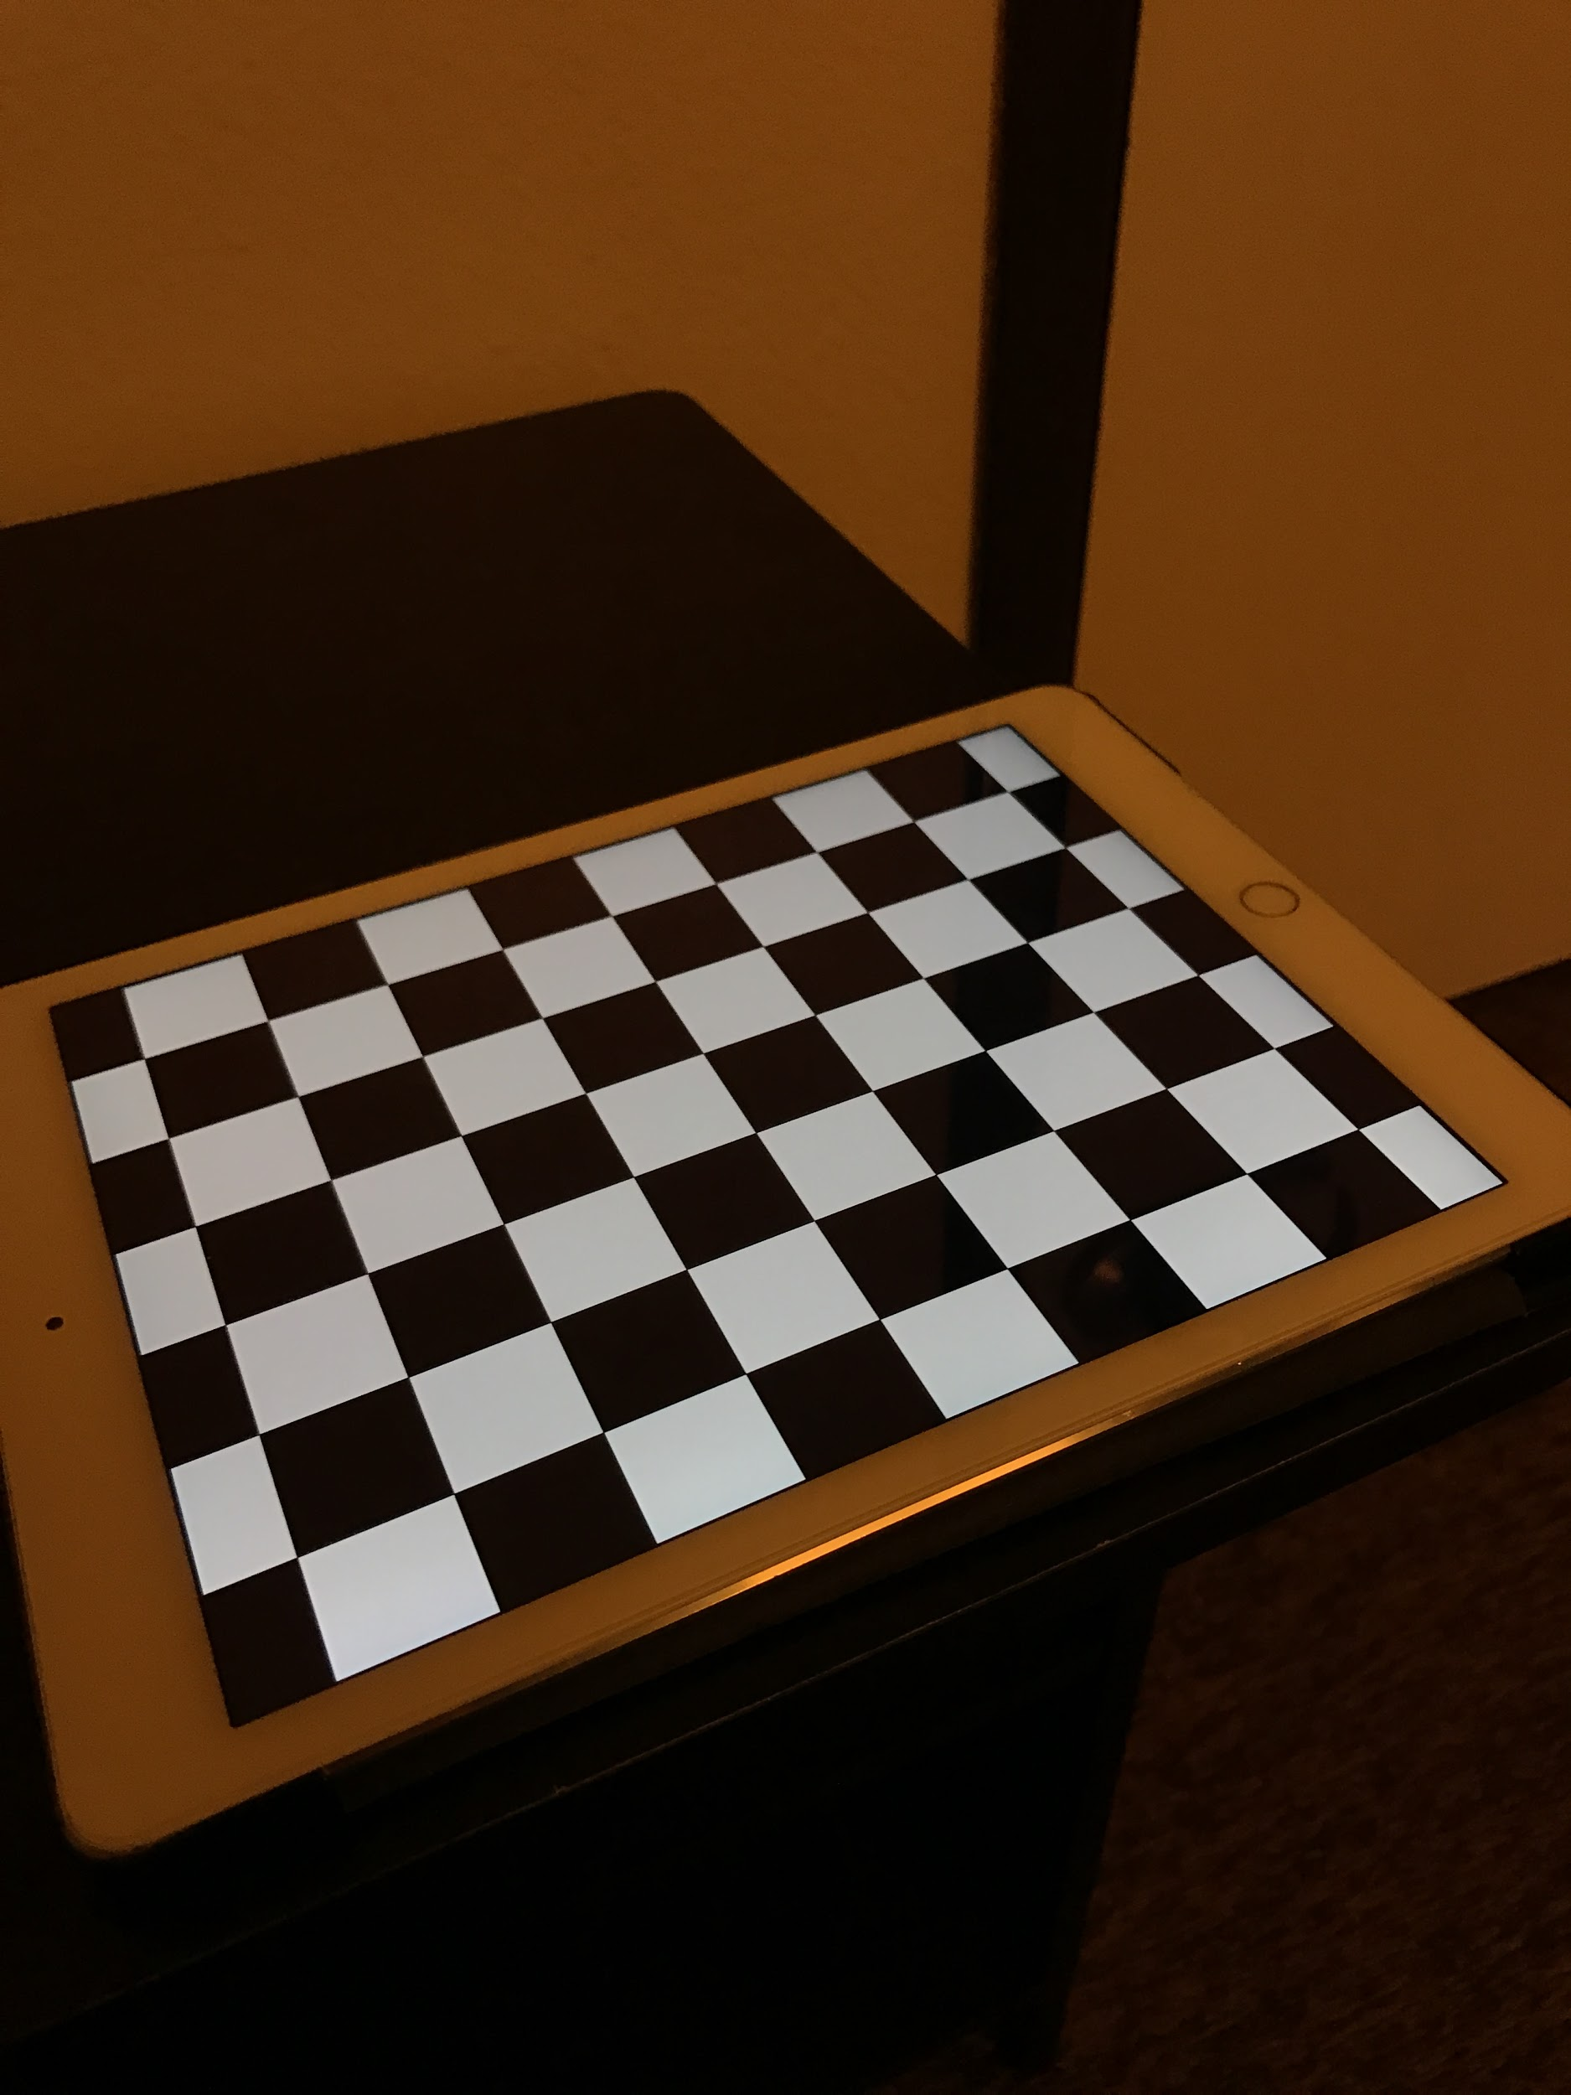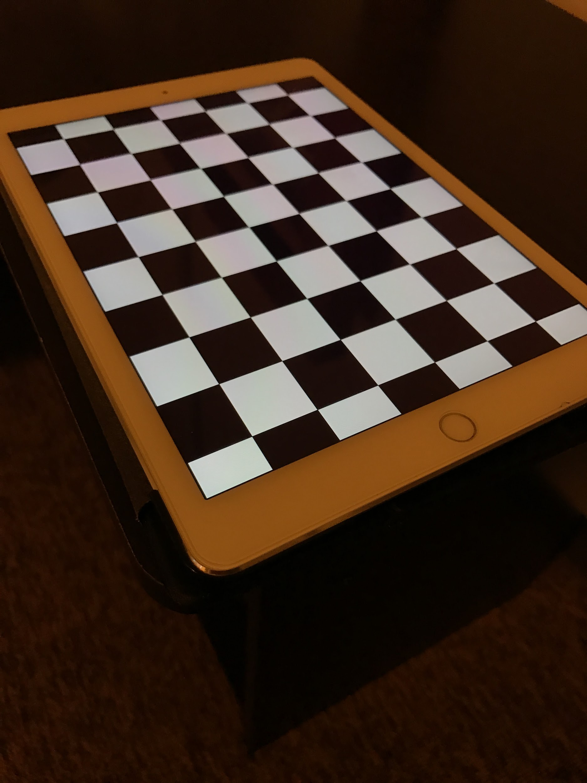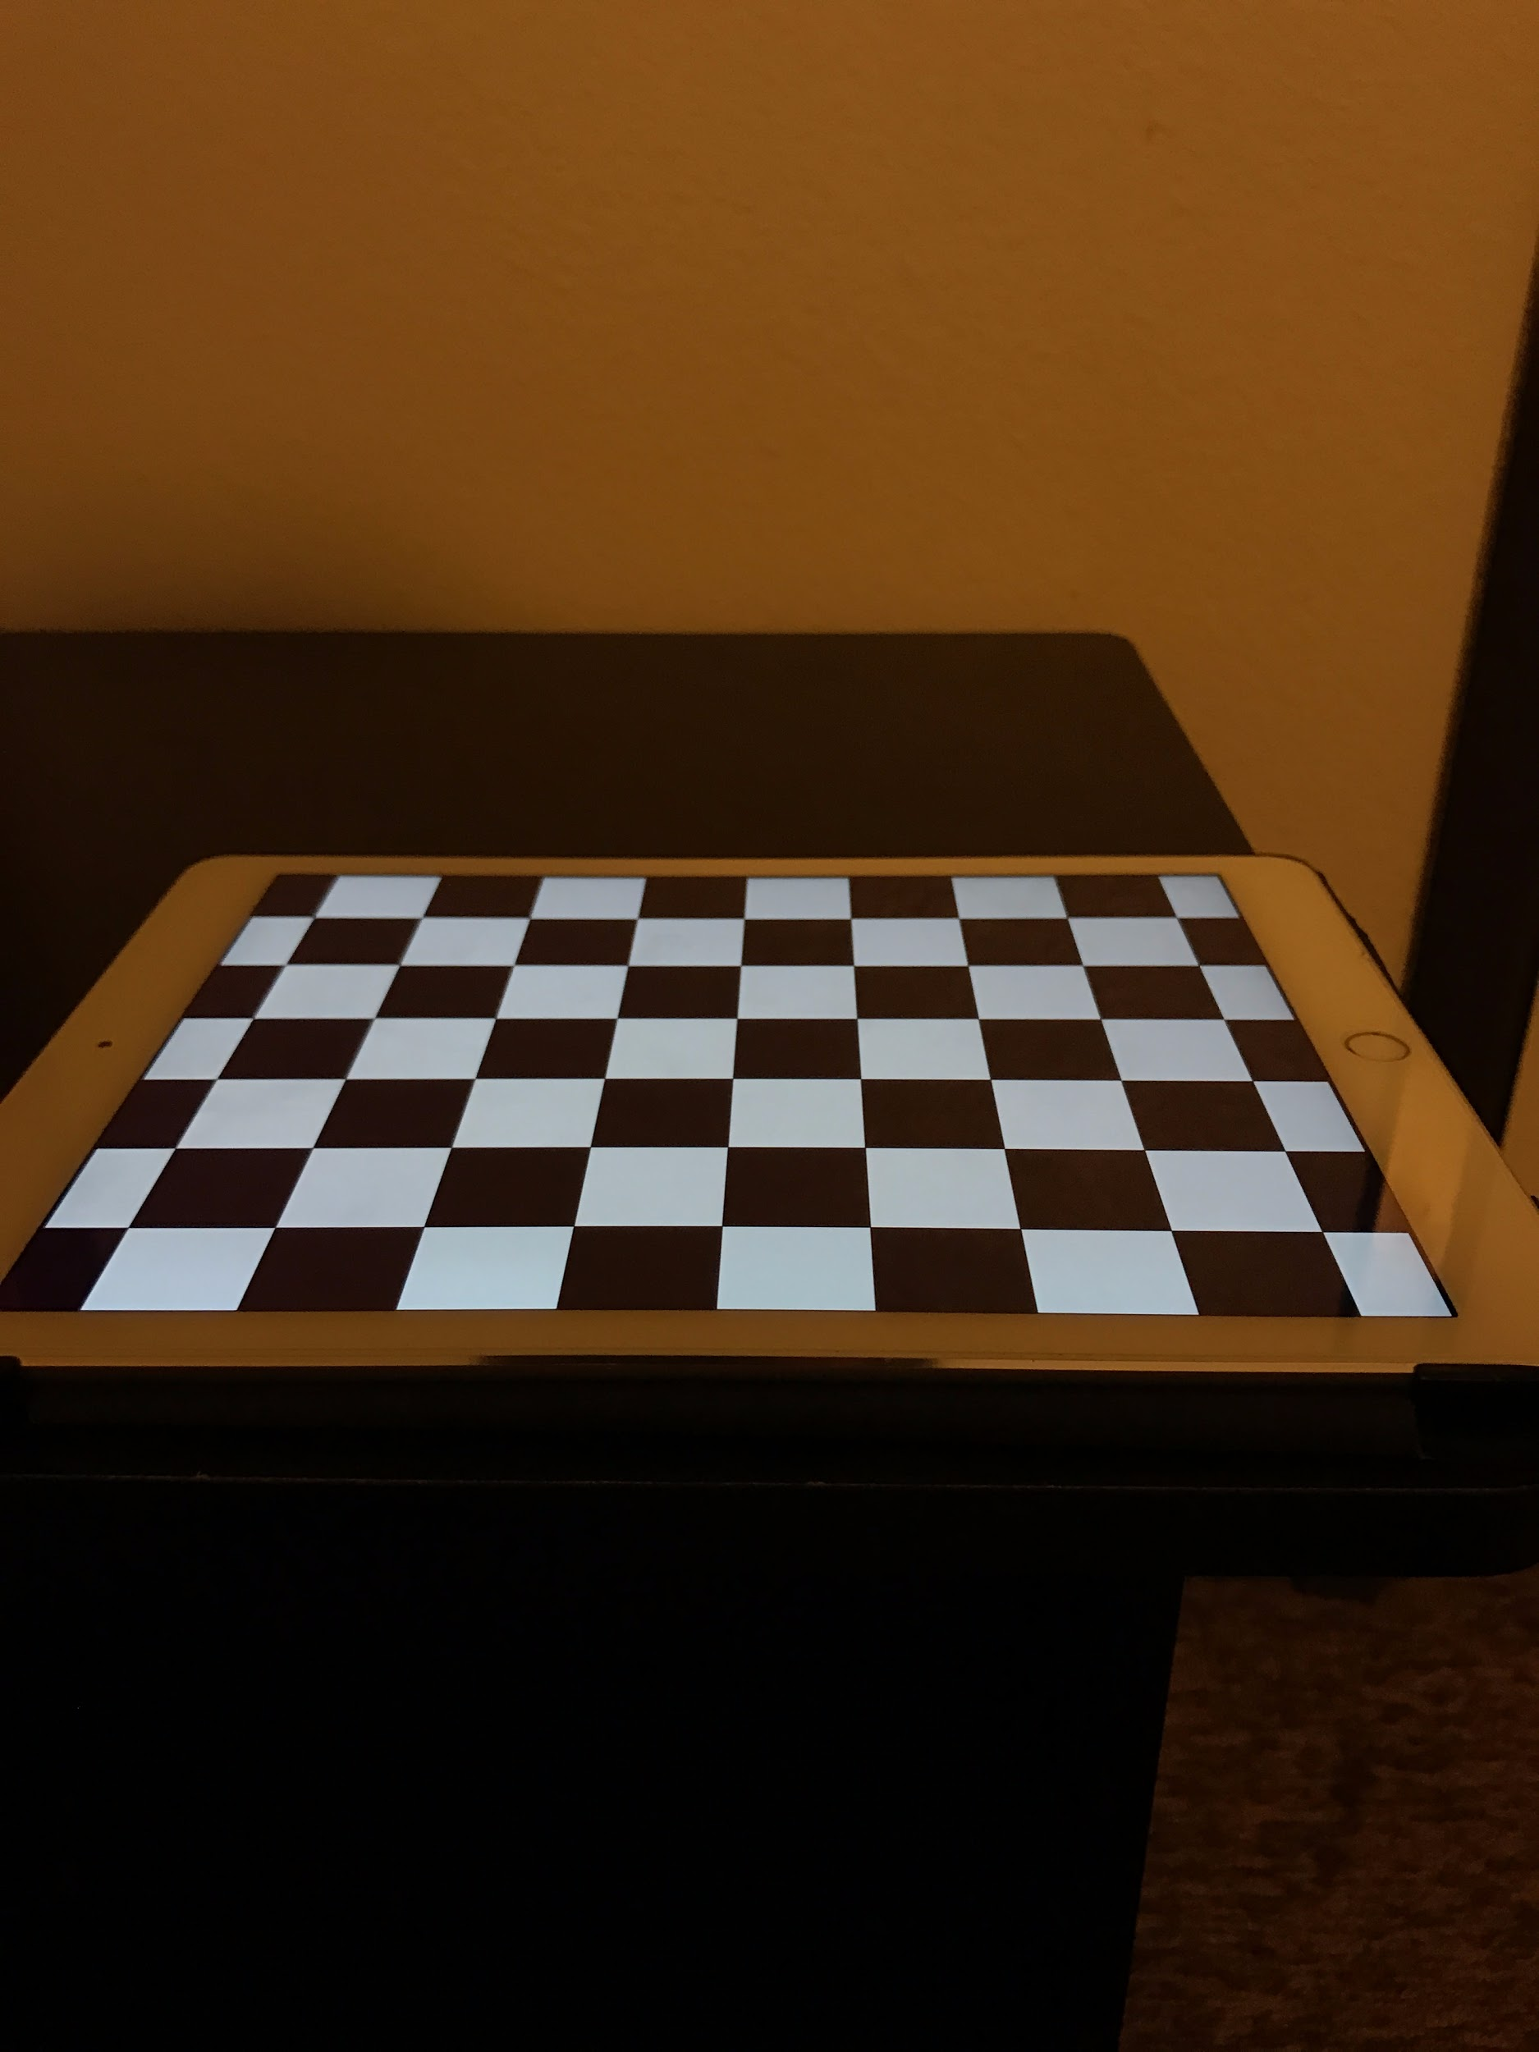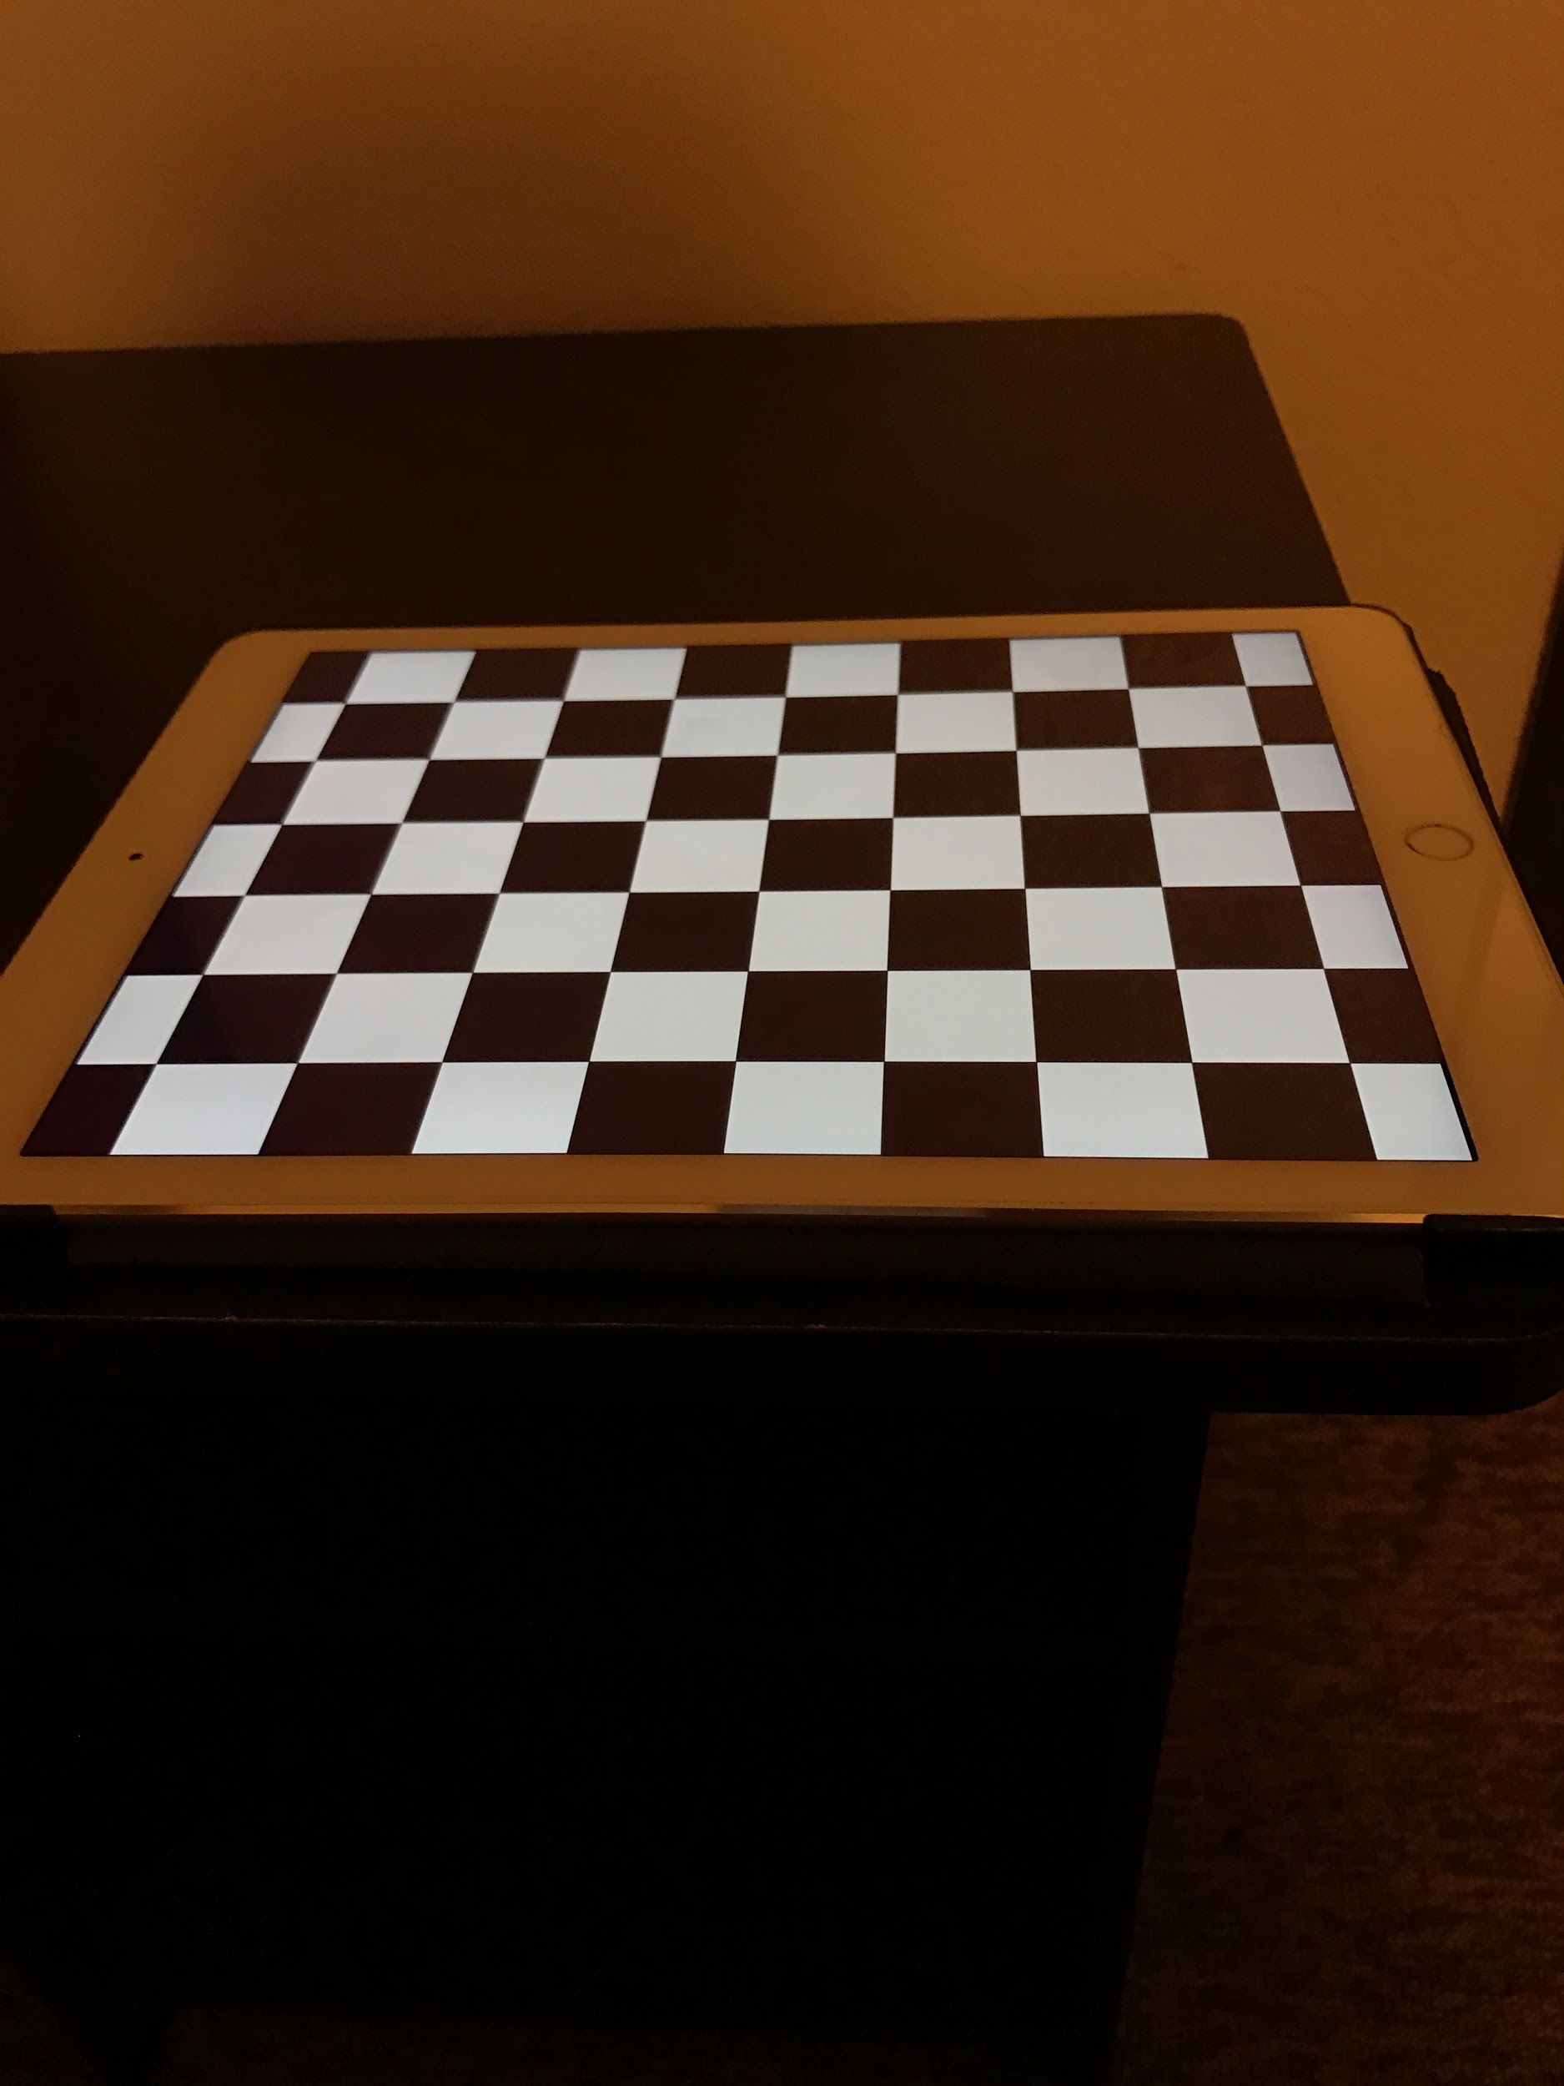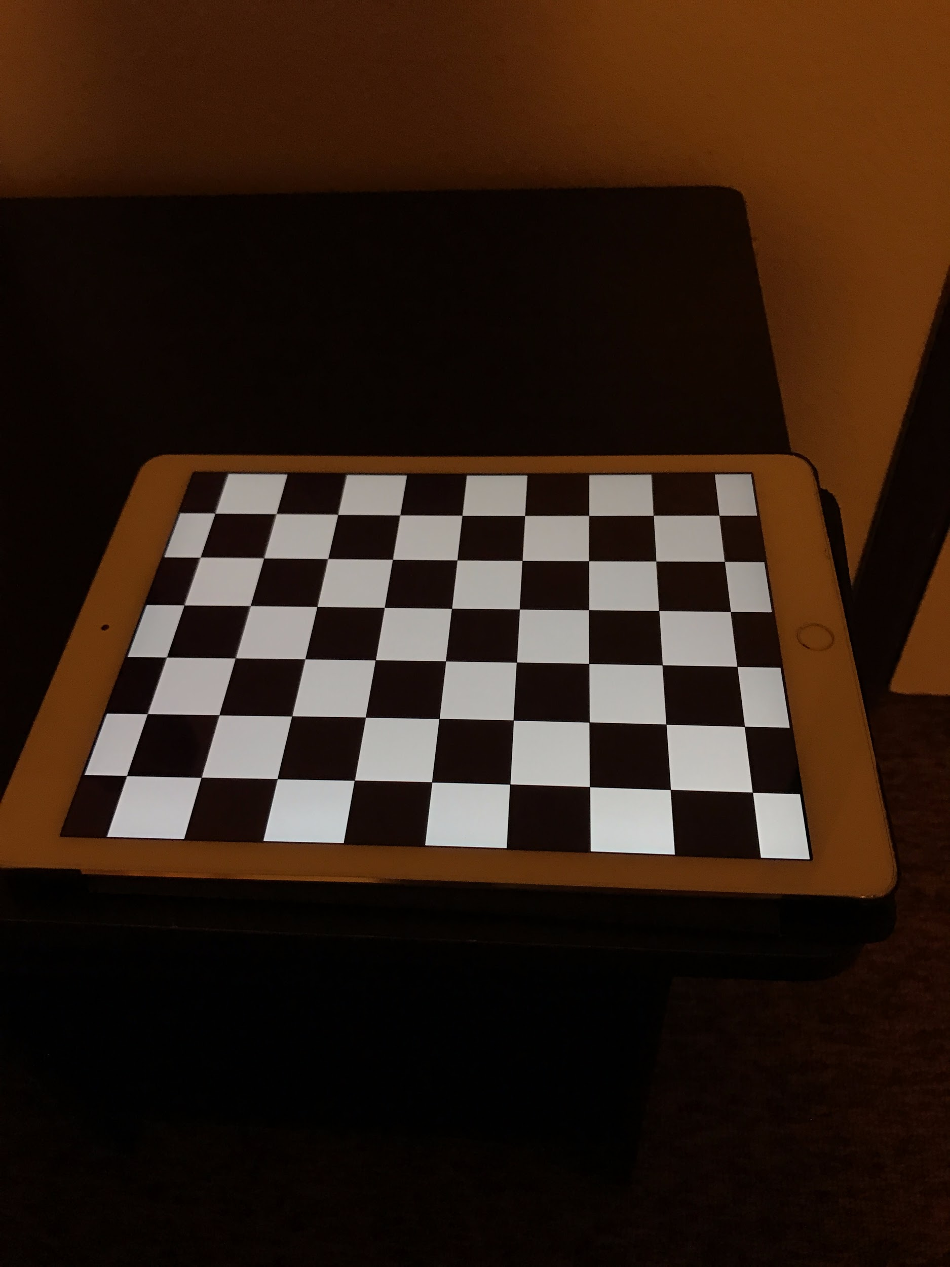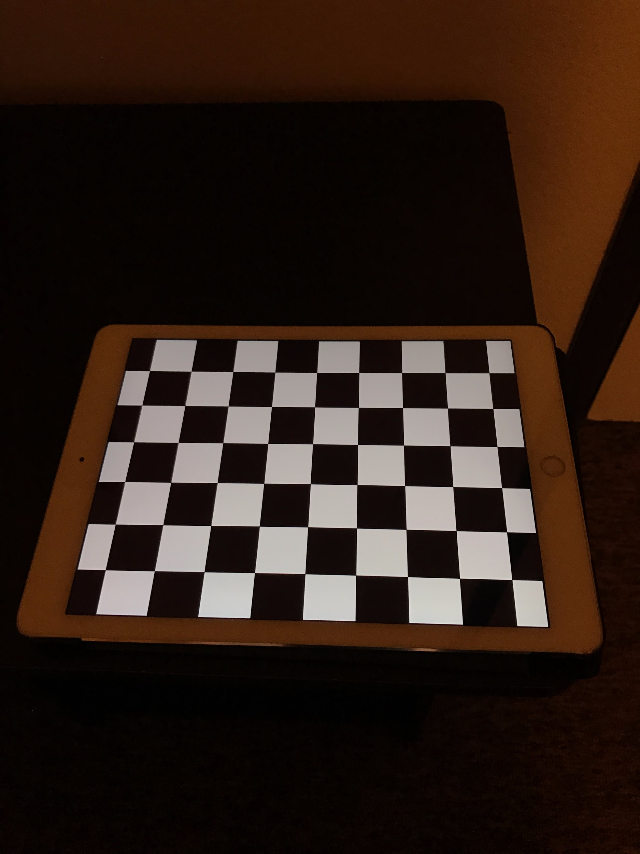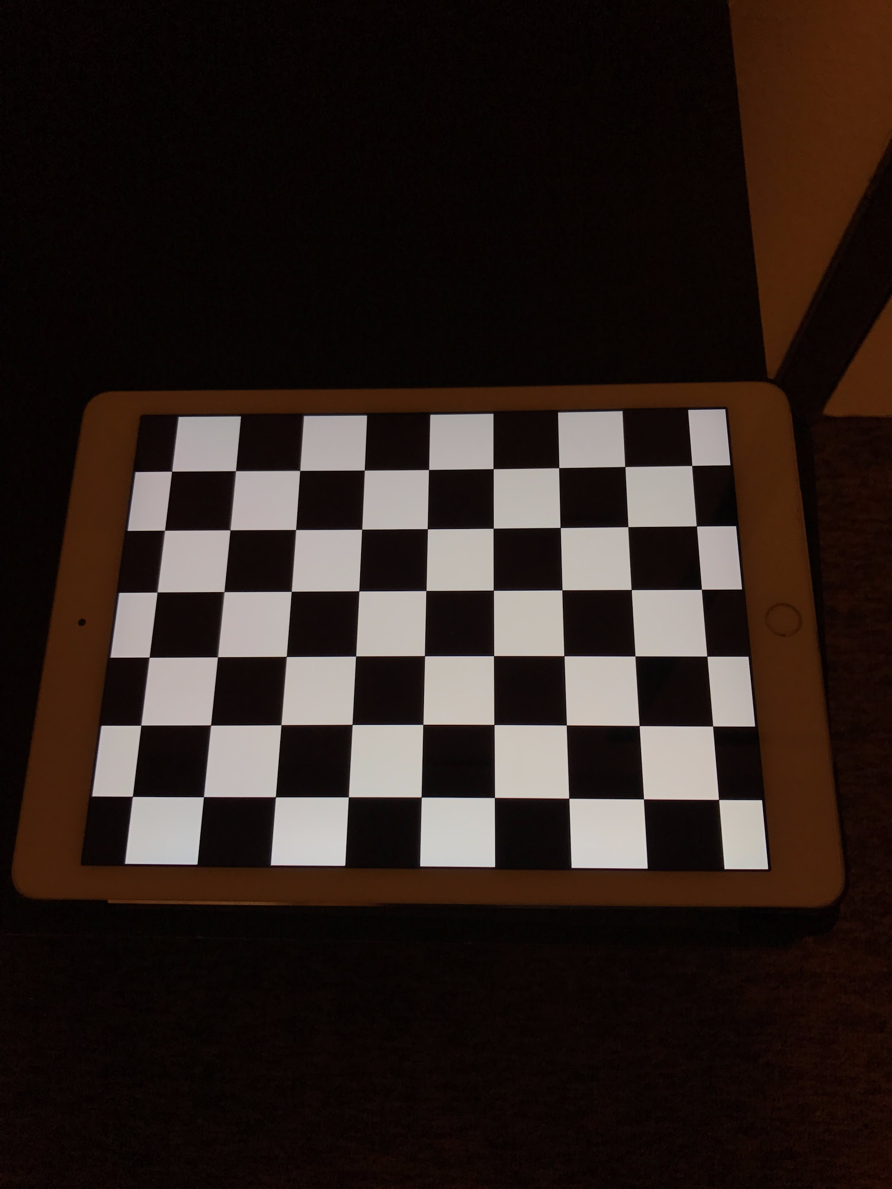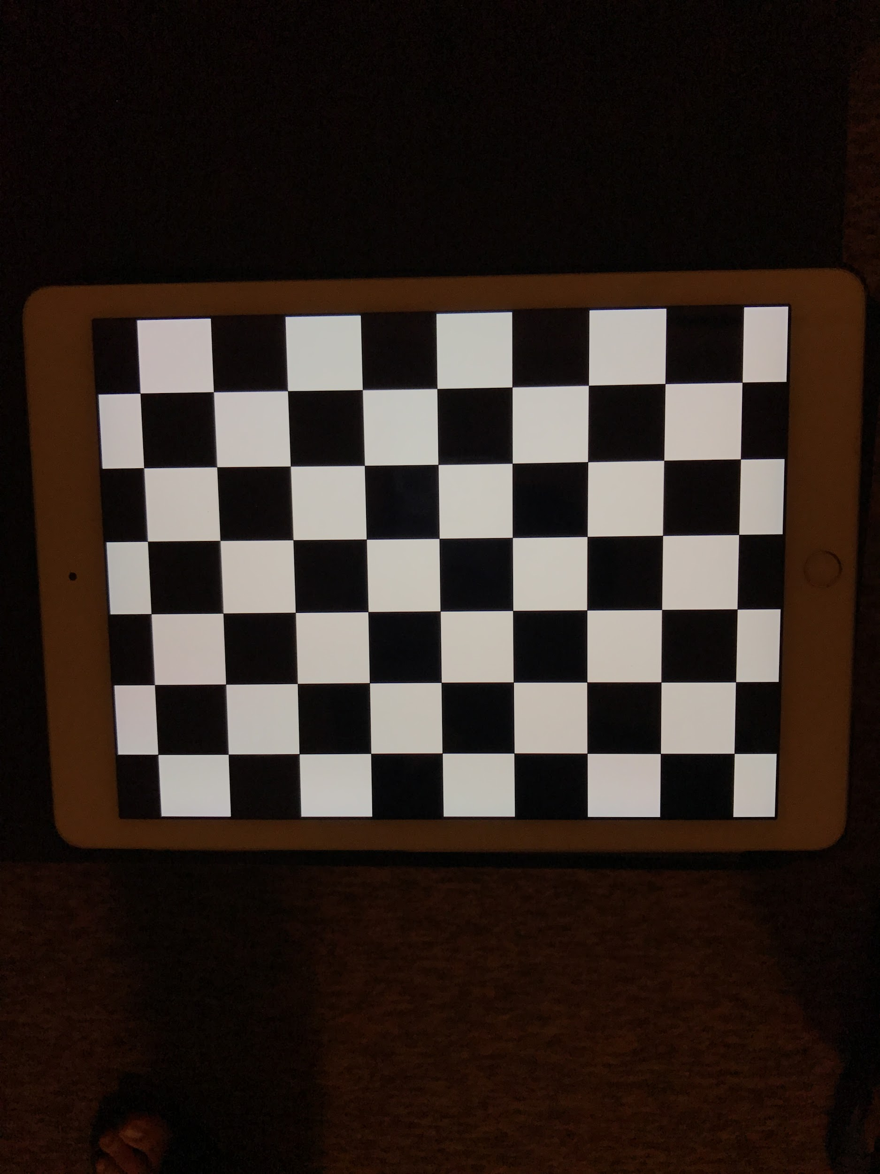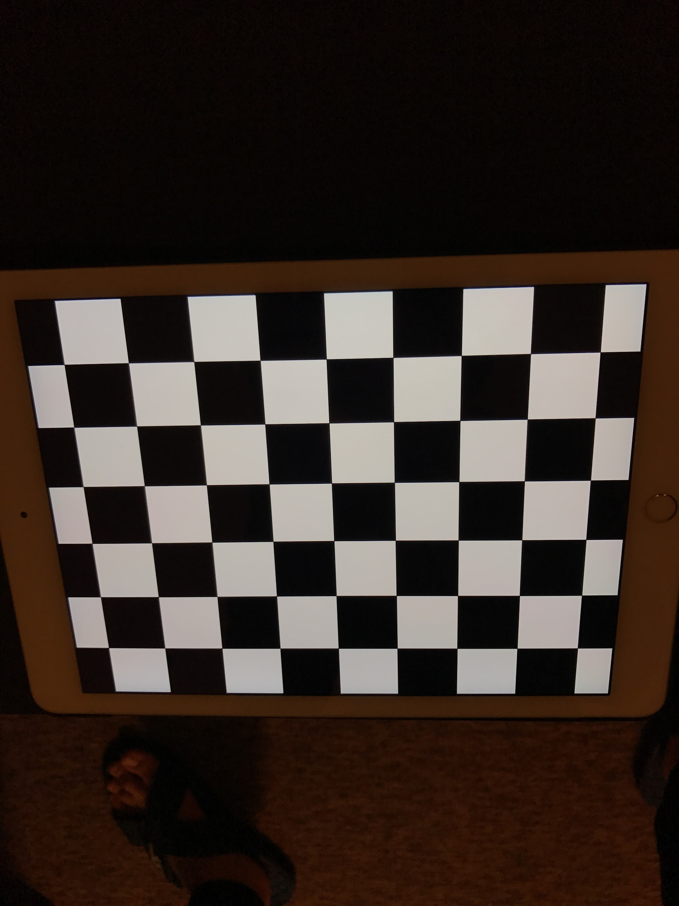

The intrinsic matrix K we’ve concluded is：

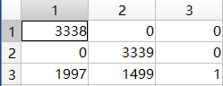

The radial distortion coefficients we’ve concluded is：

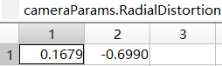

The reprojection mean error we’ve computed is:

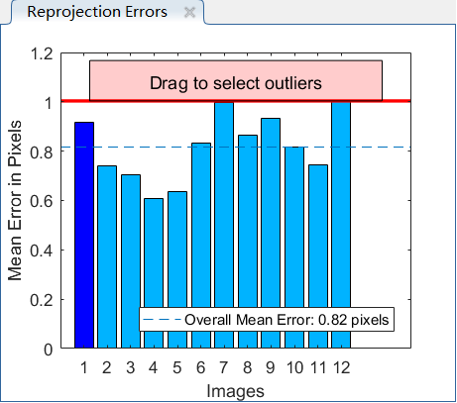

As the graph shown above we can find that the mean error is less than 0.82 pixels,

which means the quality of calibration is good enough to move to the next step.

This is the extrinsics that function generated:

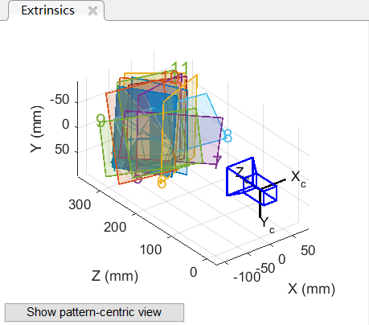

**Part 2: Taking Pictures**

We took three pictures of a scene with objects at different distances. The pictures are taken from different viewpoints, and with different camera orientations. In order to be more accurate for the next steps, we keep the camera appreciable parallax when taking these pictures. There is a substantial part of the scene visible in all three images.

Here are three pictures we took:

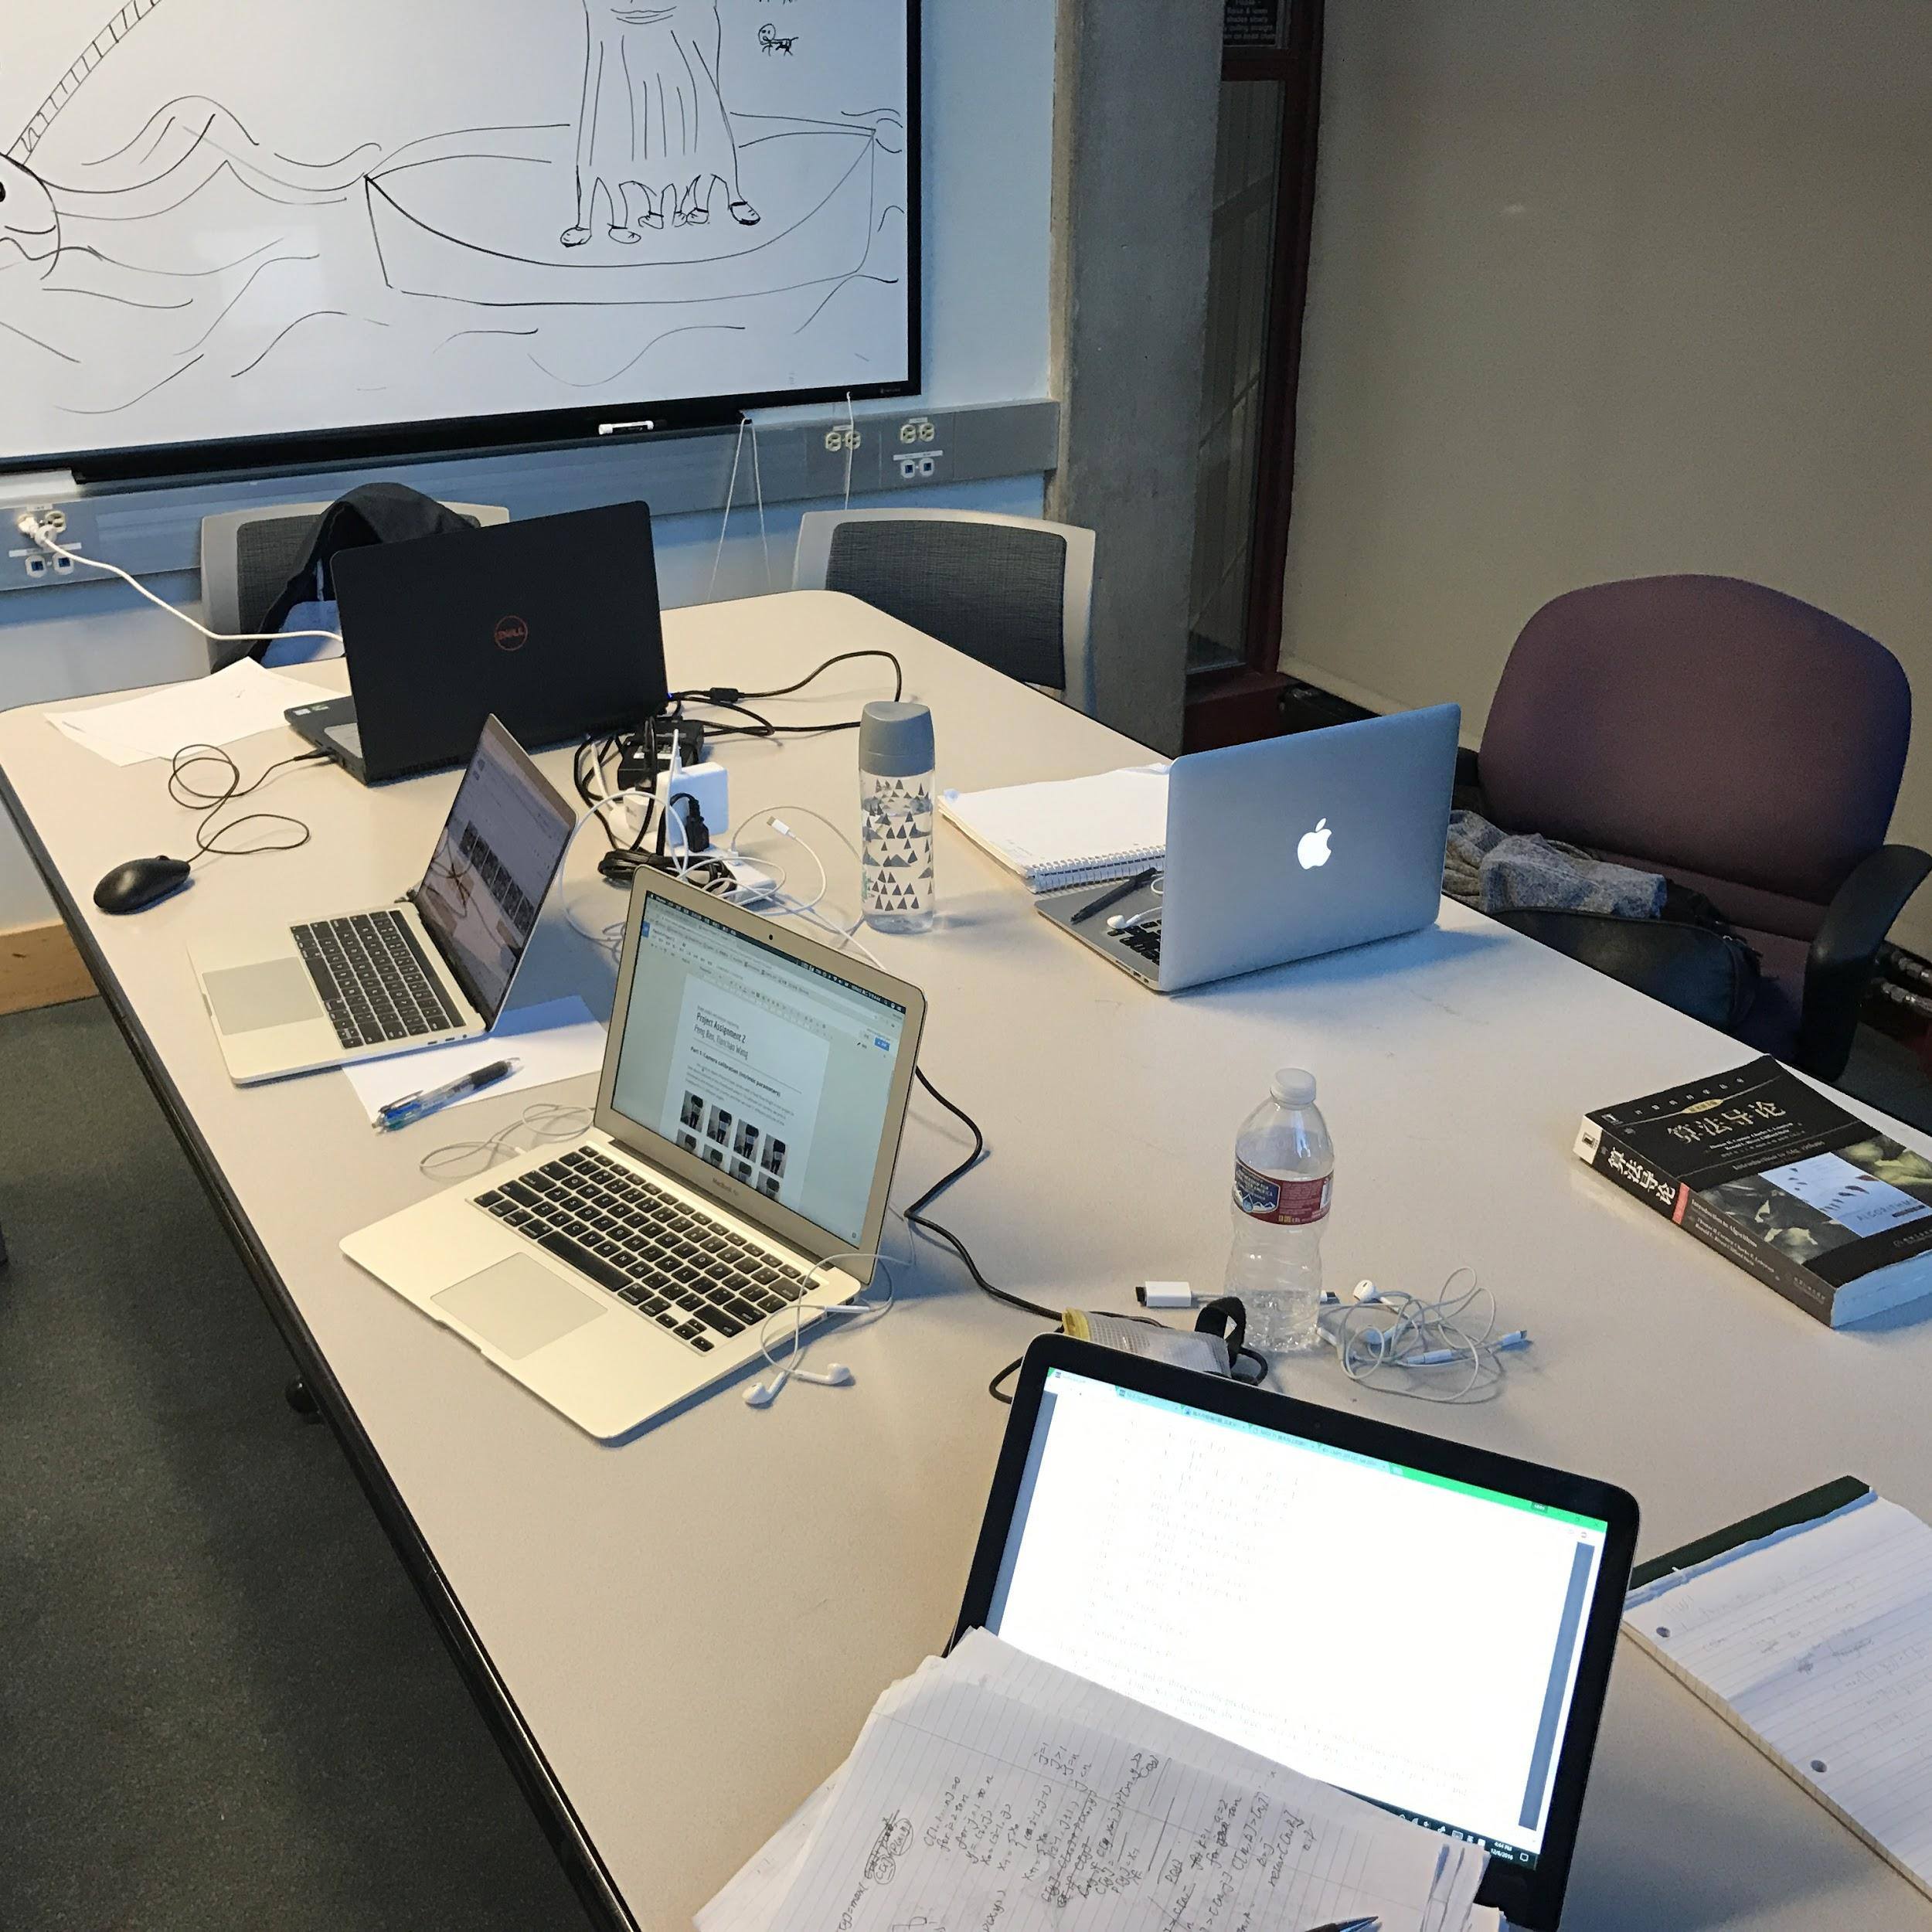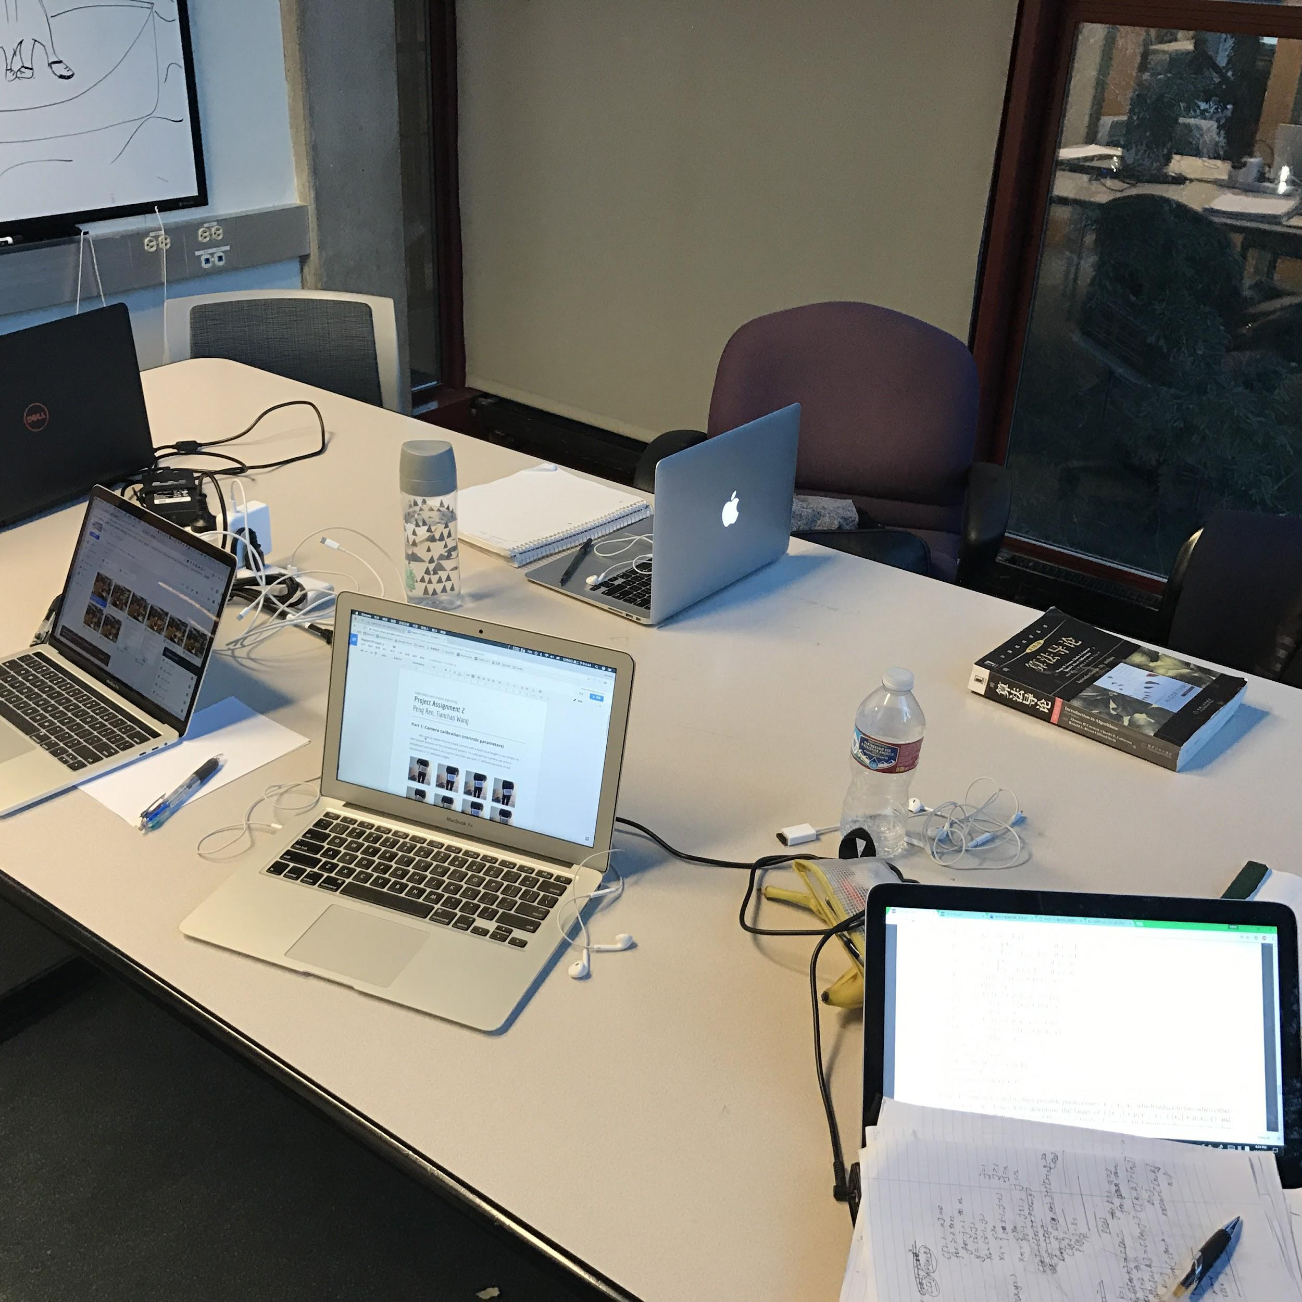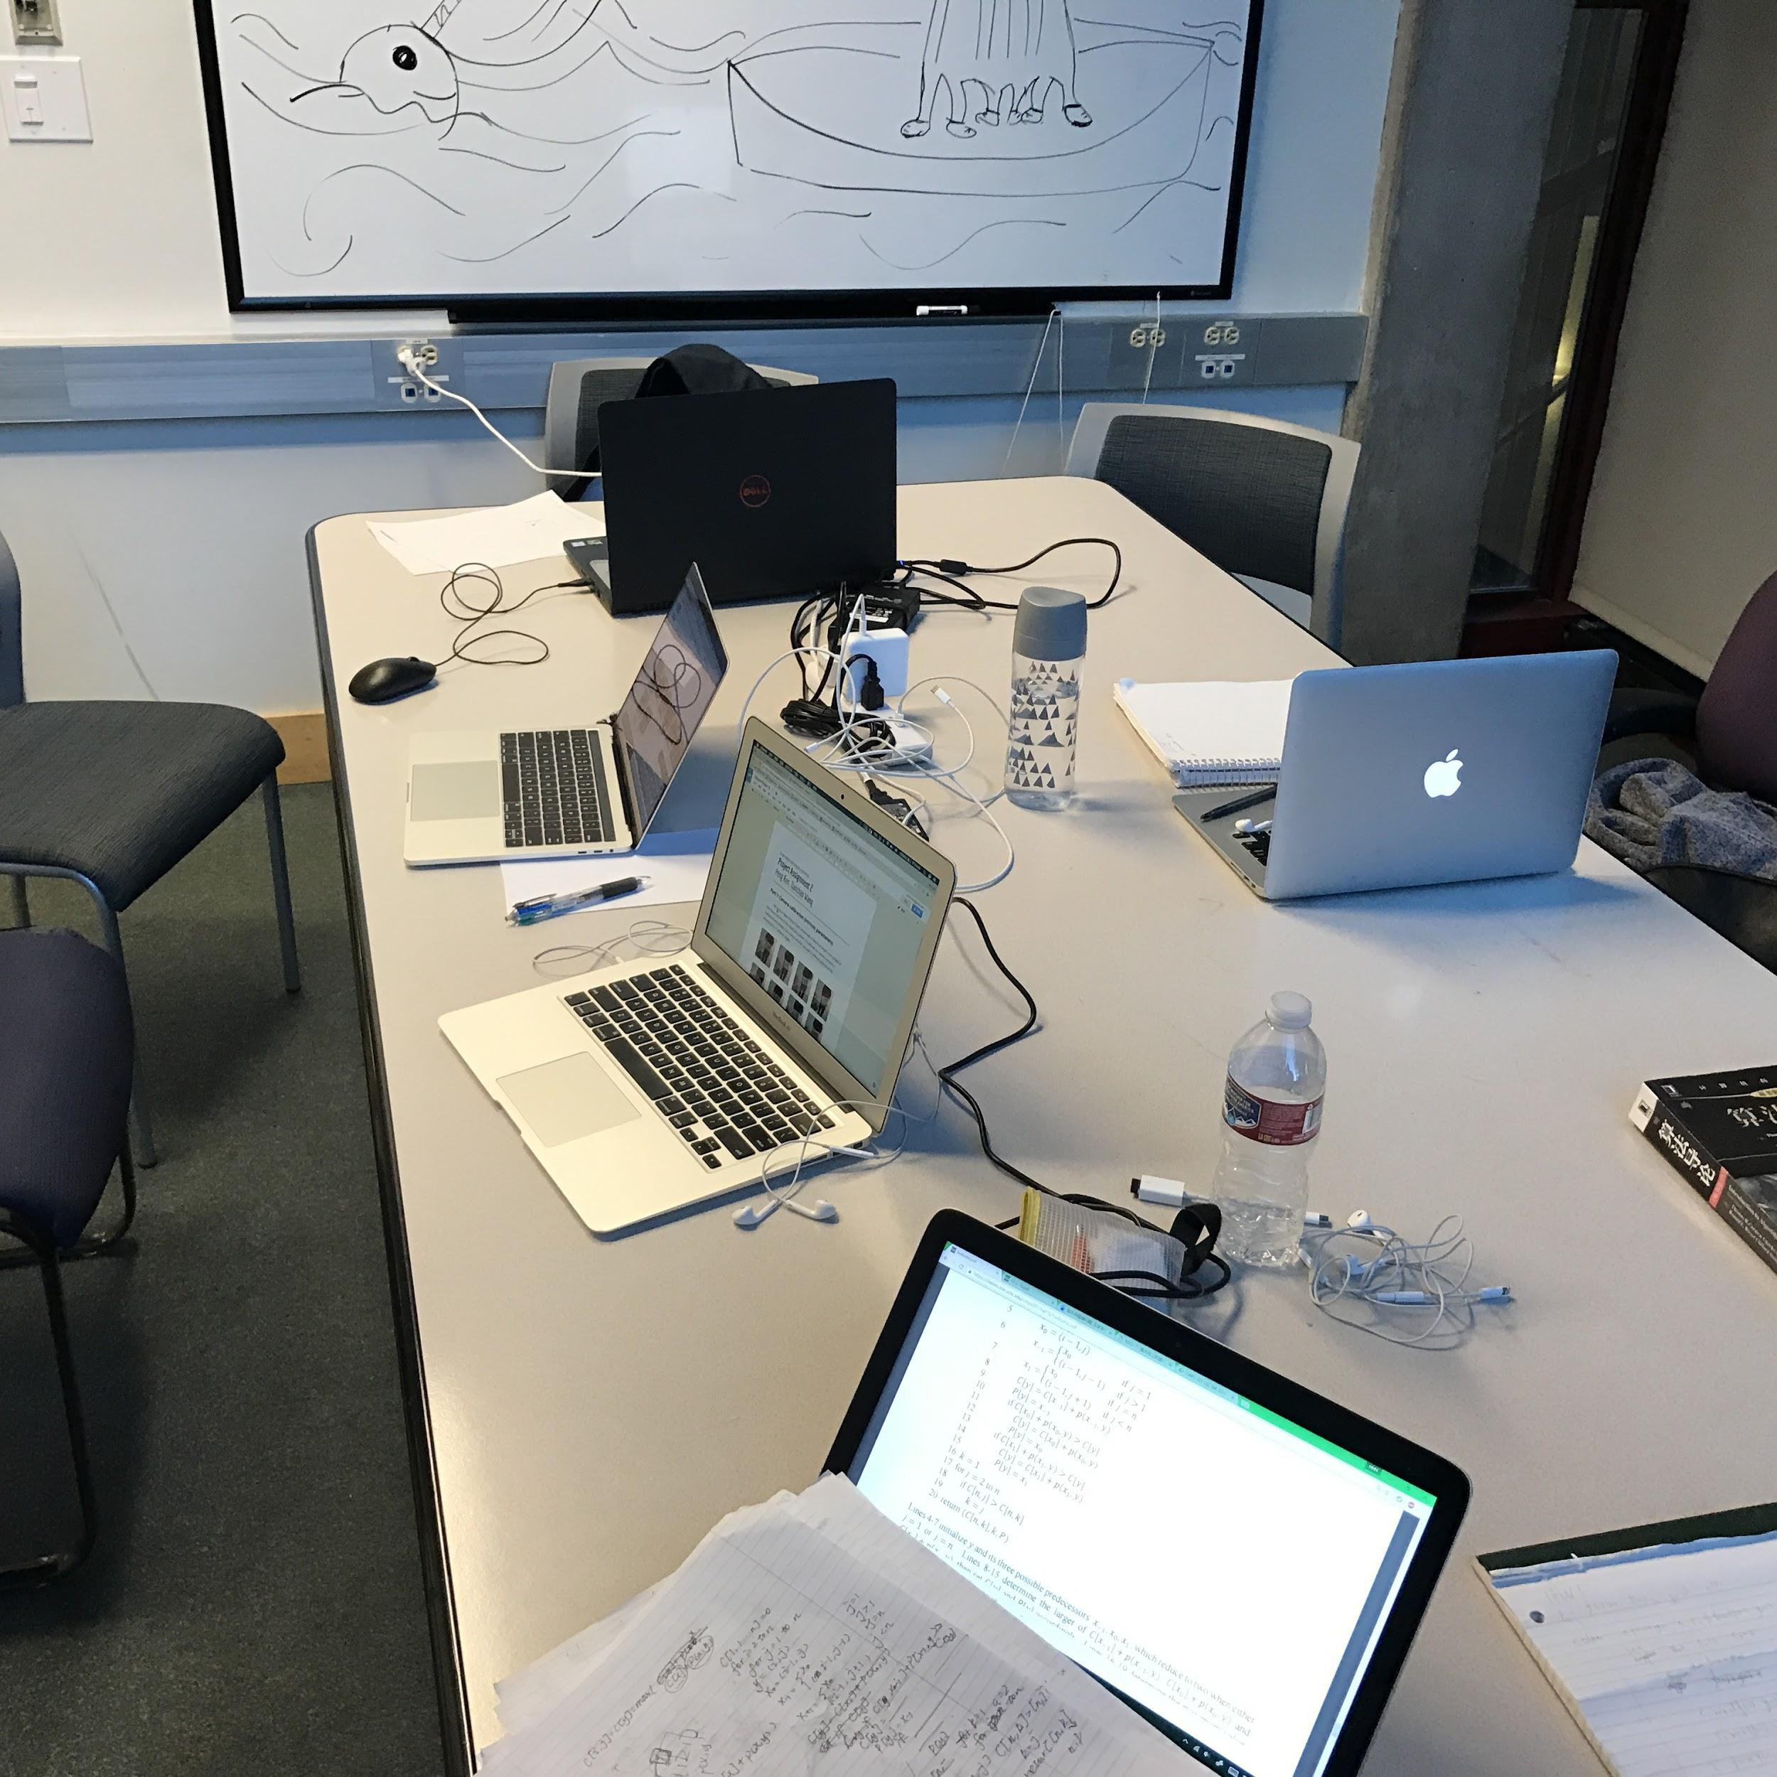

**Part 3: Compute the essential matrix of all three camera pairs.**

To compute the corresponding essential matrix E, It requires us to select candidate matching points across the two images.

1. The first thing we do is to “undistort” the images. We use undistortImage() function in matlab.
2. To select candidate matching point pairs, we use cpselect() function to select the points manually. By clicking the points on first image and clicking the matching points on the second image. We selected 17 points for each pair.
3. Then we get the matrix of two sets of matching points’ coordination.
4. By functions findEssentialMat() and findFundamentalMat() we could get Fundamental Matrix and Essential Matrix.
5. Then we plot the epipolar lines for each pair and showing the inliers by yellow circle and outliers by white cycle.

Here are the matching points I selected by hand (As an example):

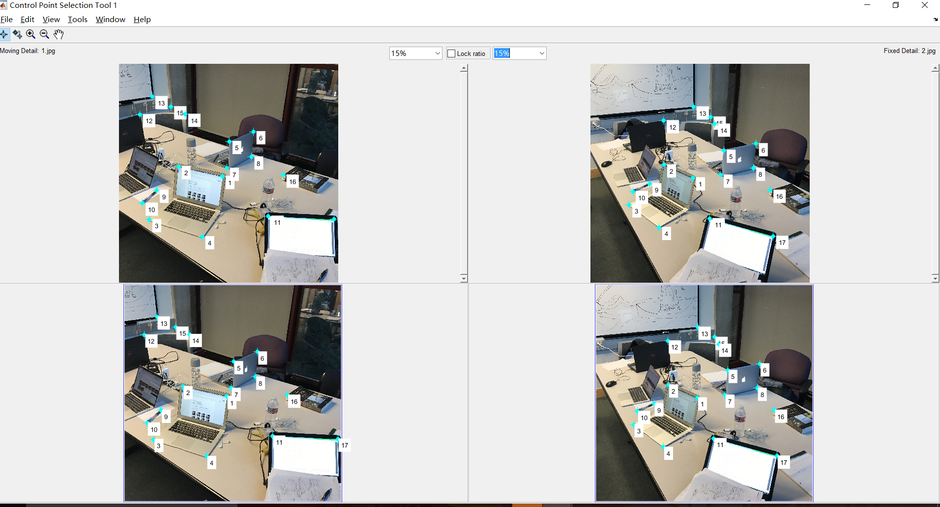

**Image1 -> image2**

Here is the first Essential Matrix:

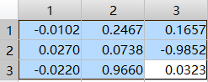

Here is the first Fundamental Matrix:

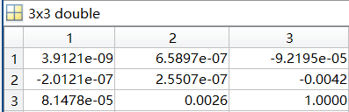

Here is the epipolar line of img1 and img2 (Inliers: yellow cycle, outliers: white cycle) :

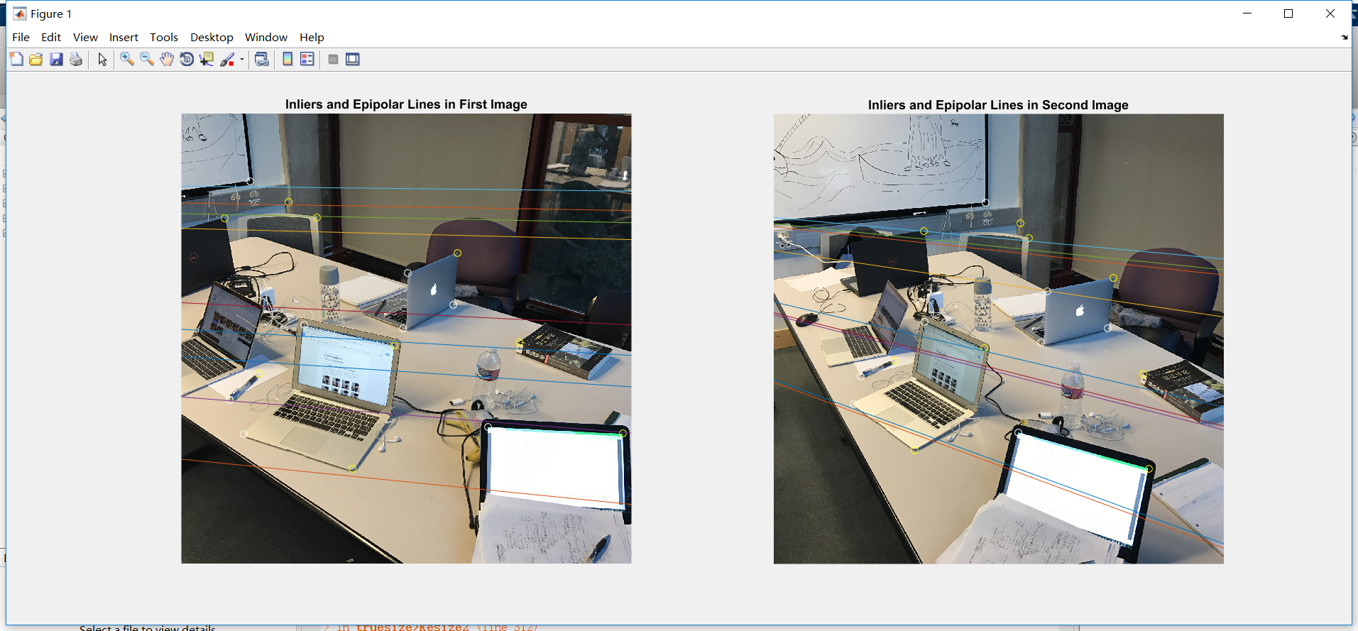

**Image2 -> image3**

Here is the second Essential Matrix:

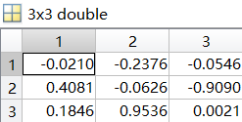

Here is the second Fundamental Matrix:

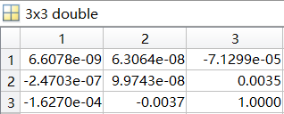

Here is the epipolar line of img2 and img3 (Inliers: yellow cycle, outliers: white cycle) :

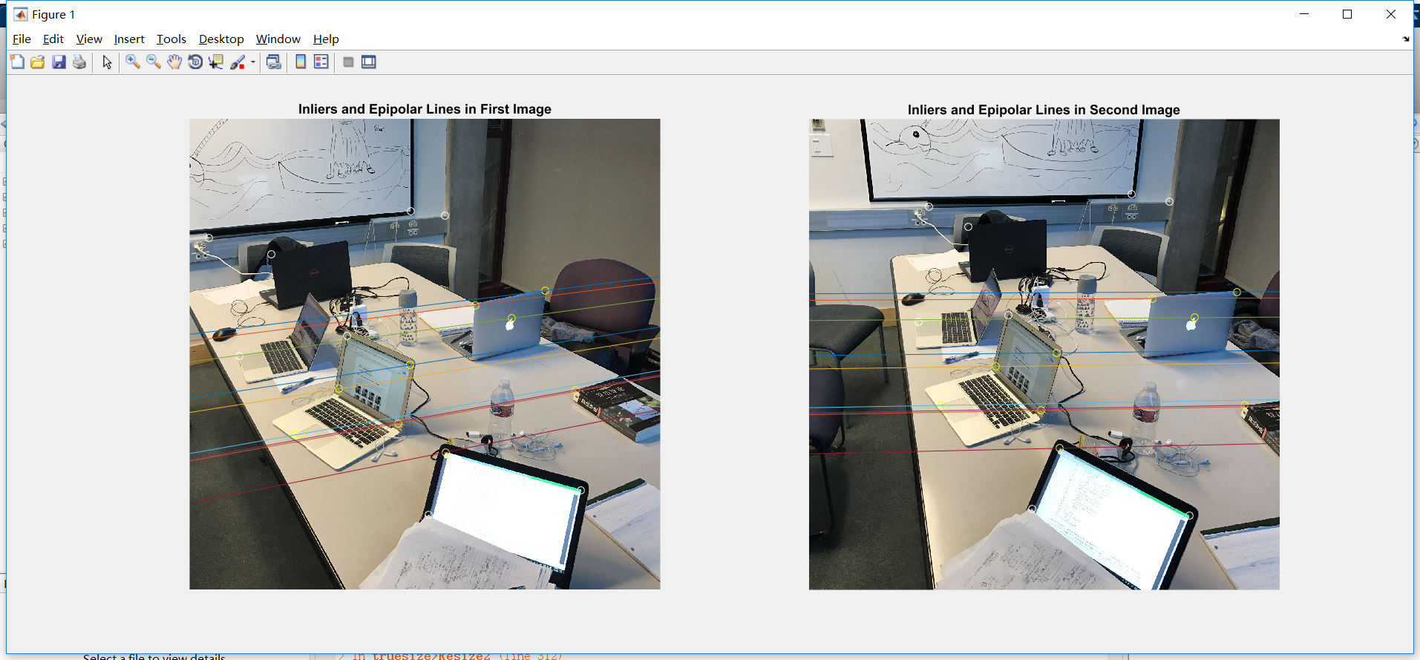

**Image1 -> image3**

Here is the third Essential Matrix:

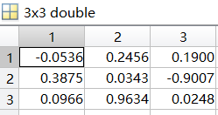

Here is the third Fundamental Matrix:

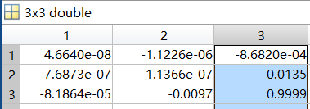

Here is the epipolar line of img1 and img3 (Inliers: yellow cycle, outliers: white cycle) :

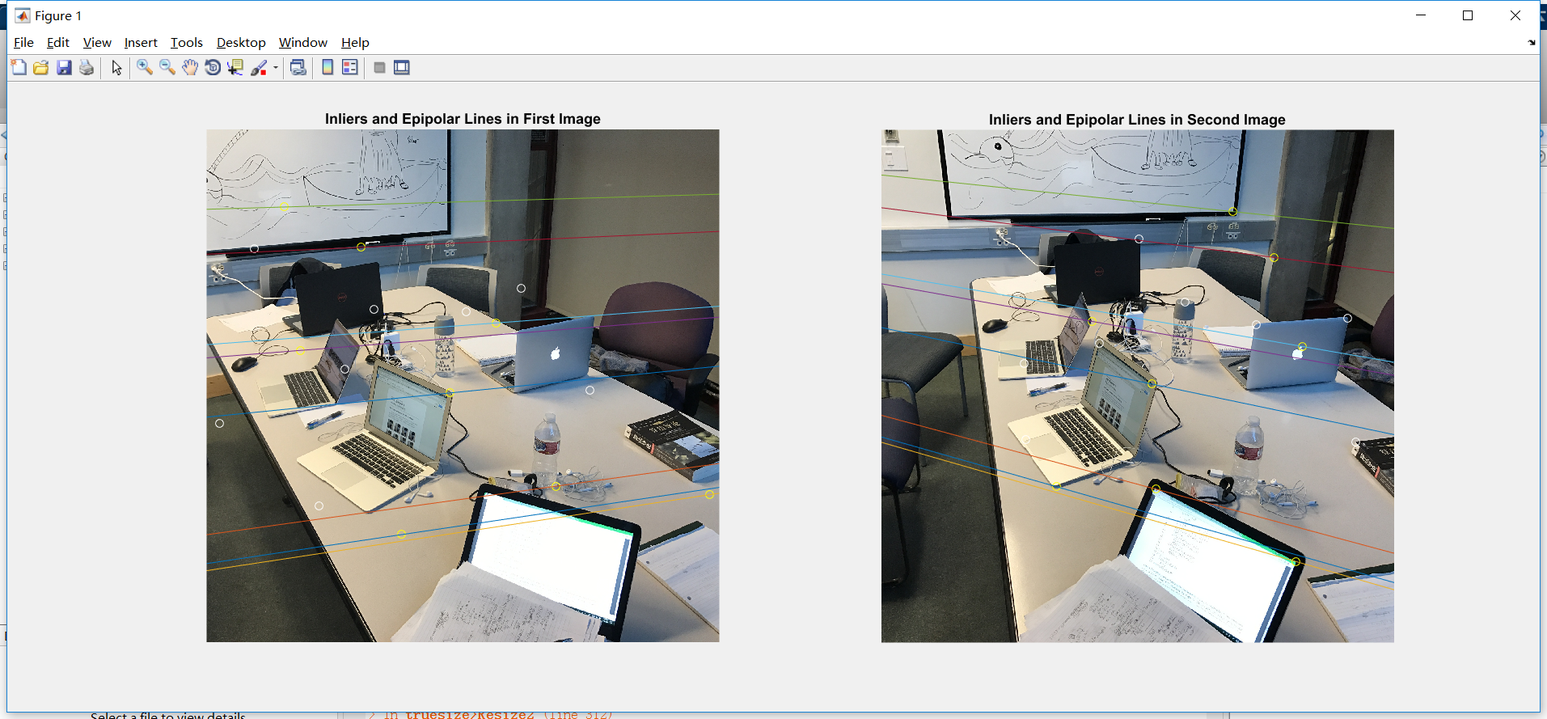

**Part4: Find the extrinsic parameters**

Here is the matrix RL and translation vector rR we found:

The first two column is the RL . Last column is rR.

**Image1 -> image2:**

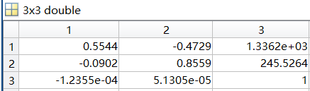

**Image2 -> image3:**

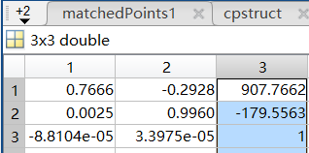

**Image1 -> image3:**

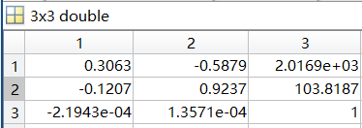

As for rest of questions,we cannot figure them out, because we cannot get the depth of all inliers.Thus we can not get the points in the second image of the pair. So we cannot compute the root mean squared reprojection error.

**Part 5: Rescale the translation vector:**

We found r122 ,r133 , r233 are three translation vectors we find, and R12, R13, R23 the rotation matrices, for the pairs image1-image2, image1-image3, and image2-image3. We only know the direction these vector. We express these vector in unit-norm. However, we can not find a right formula to calculate the the β and γ. We can only list the formula as follow.

r122 + βr133 + γ⋅r233 =0

**Part 6: Plane-sweeping 2-views stereo:**

We use disparity function in matlab to obtain a distance map for image1-image2 and image2-image3.Yellow part means the object is closer to the camera. Blue part are far away.

**Image1 -> image2:**

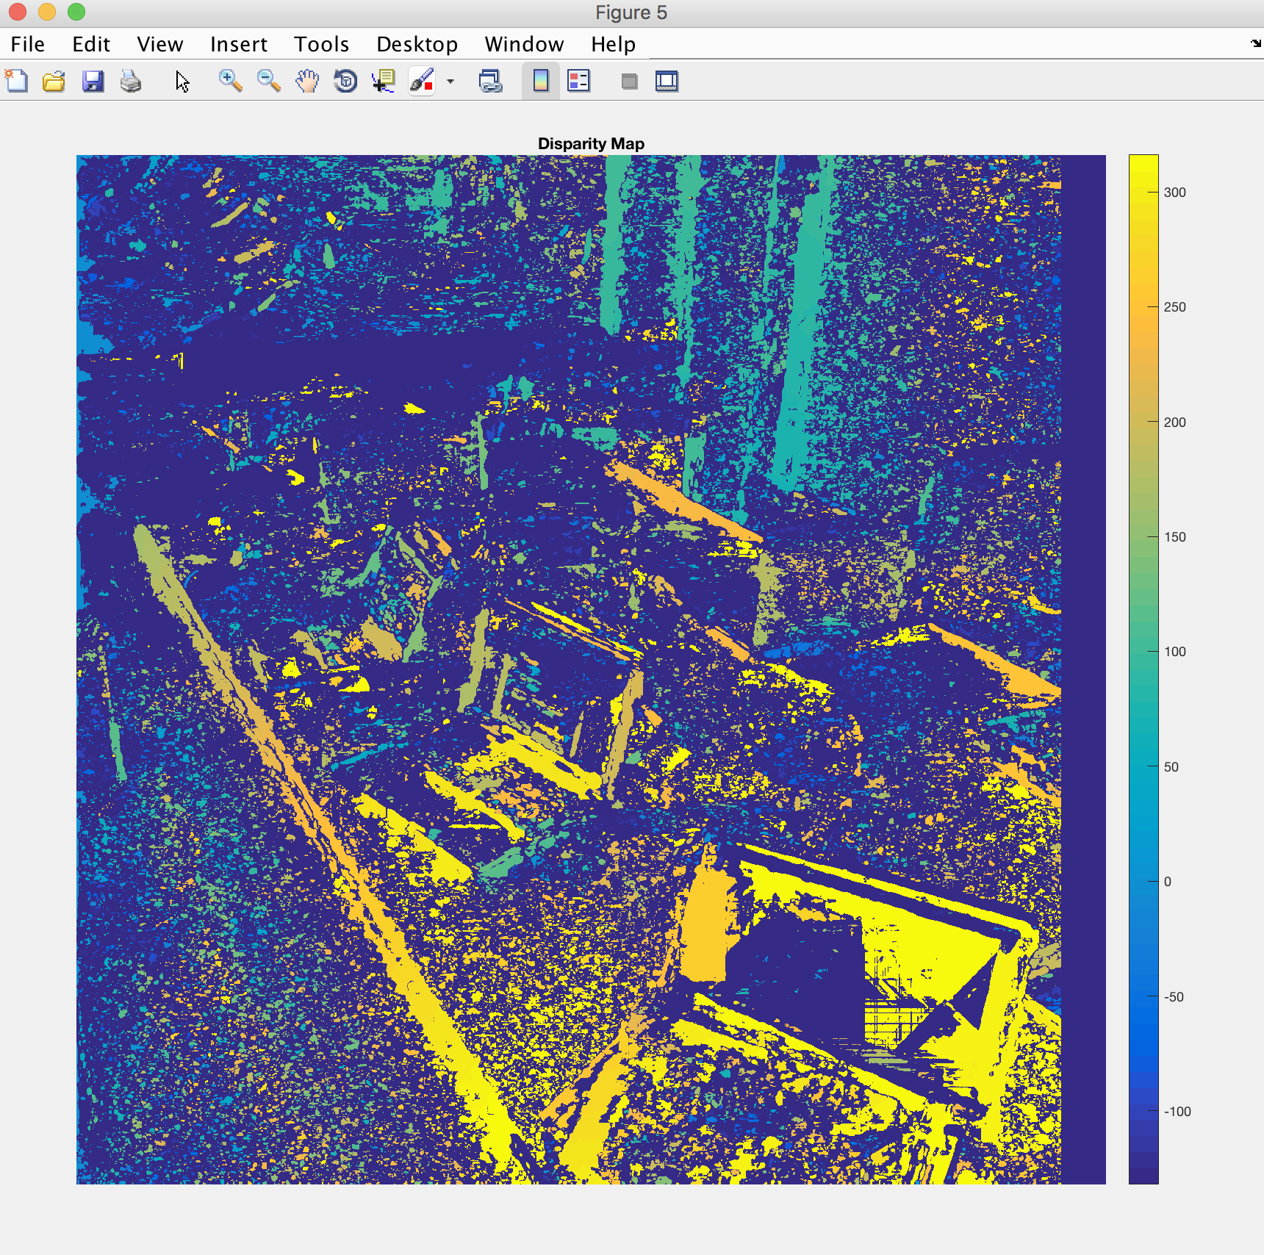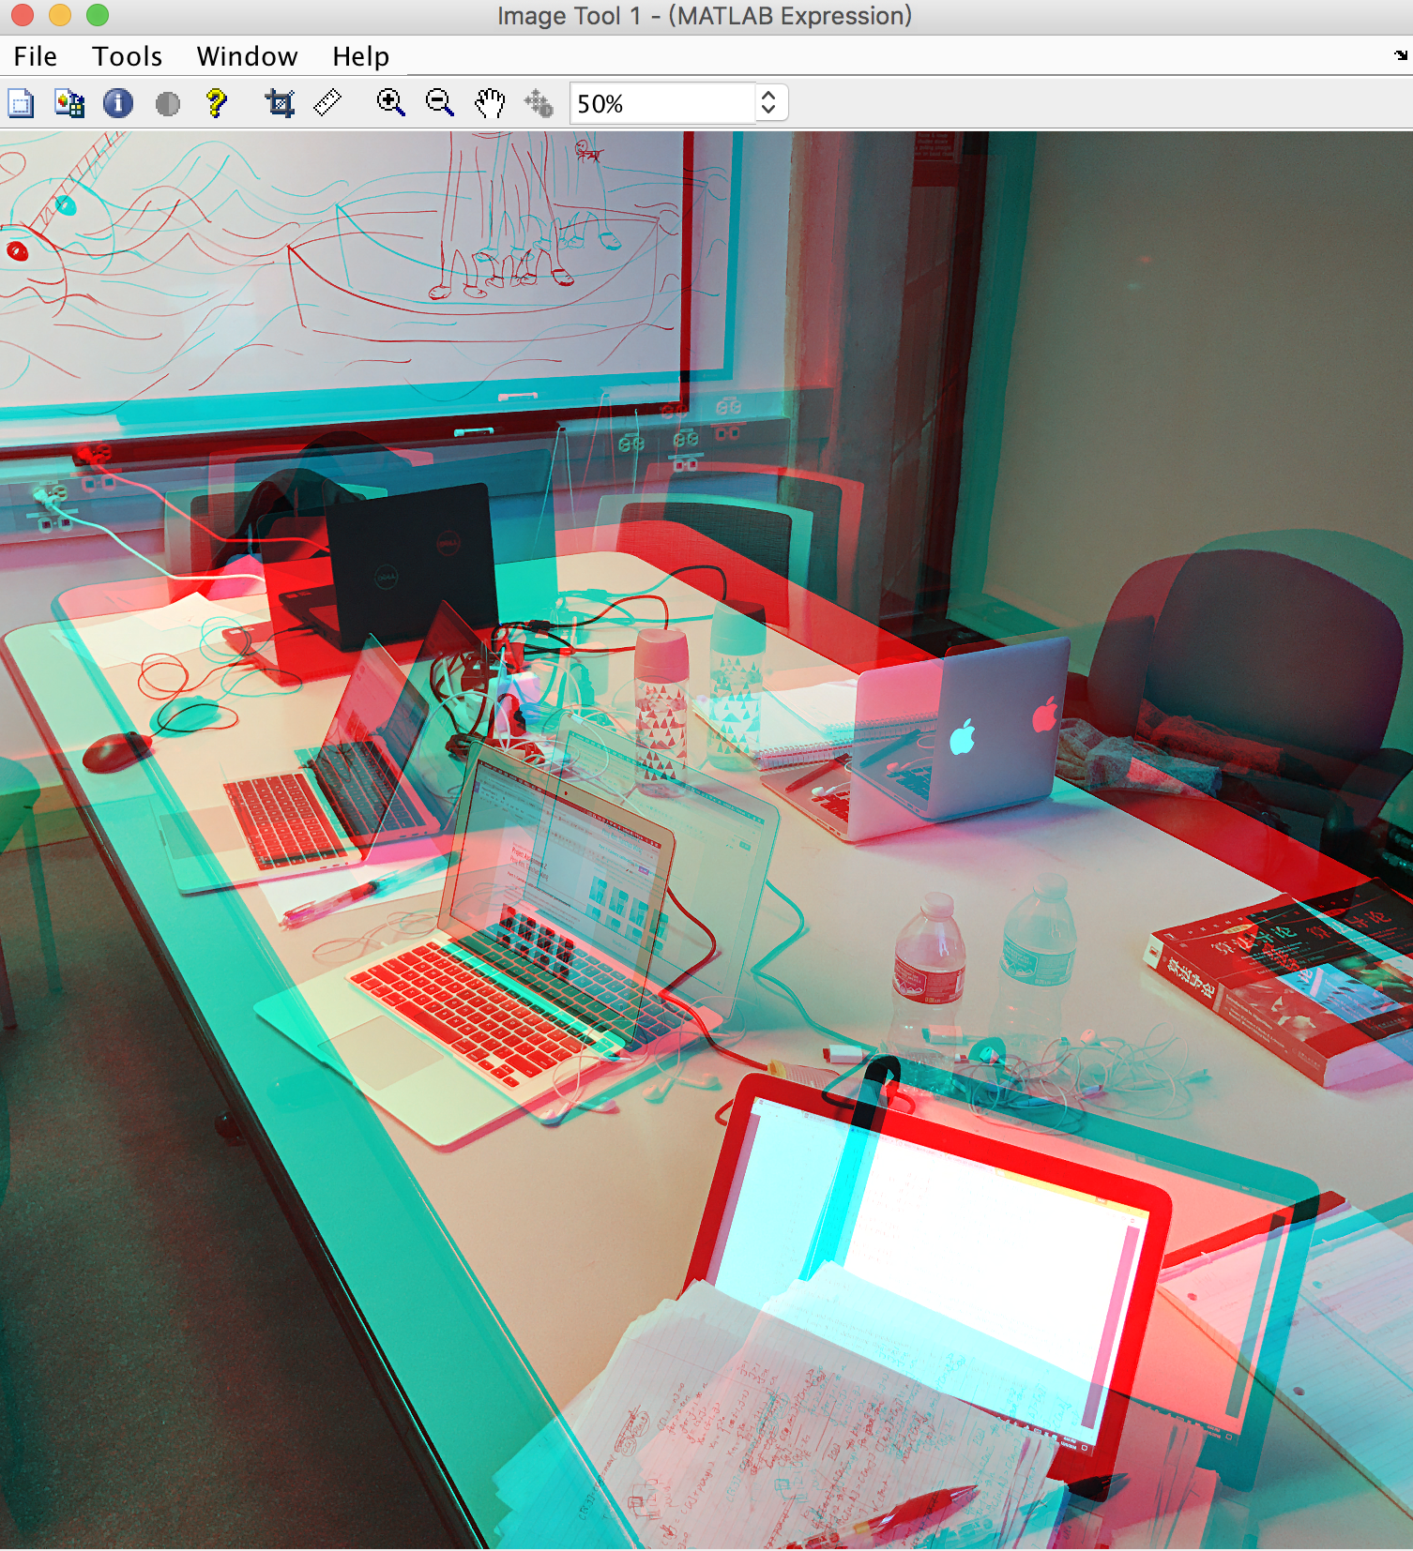

**Image2 -> image3:**

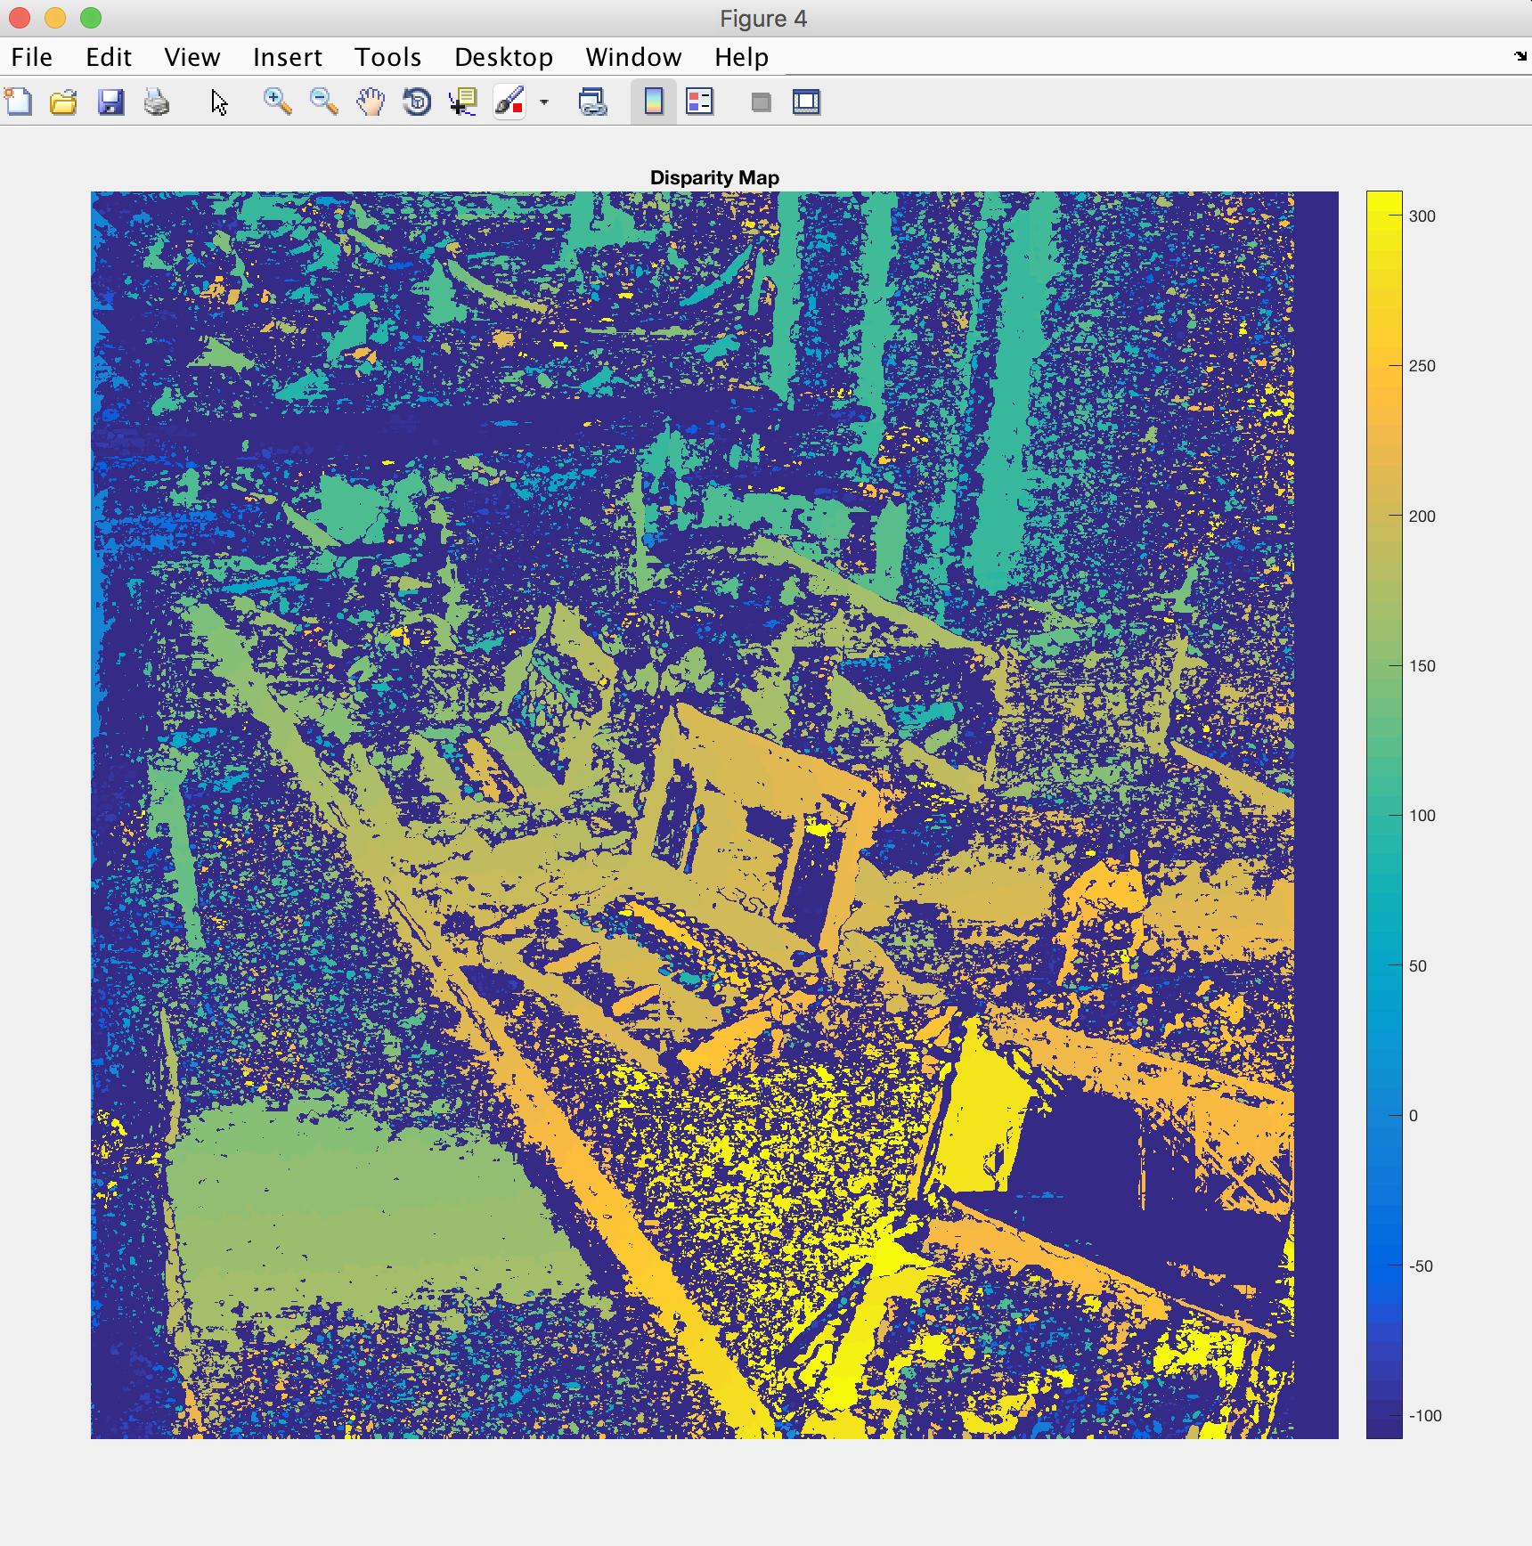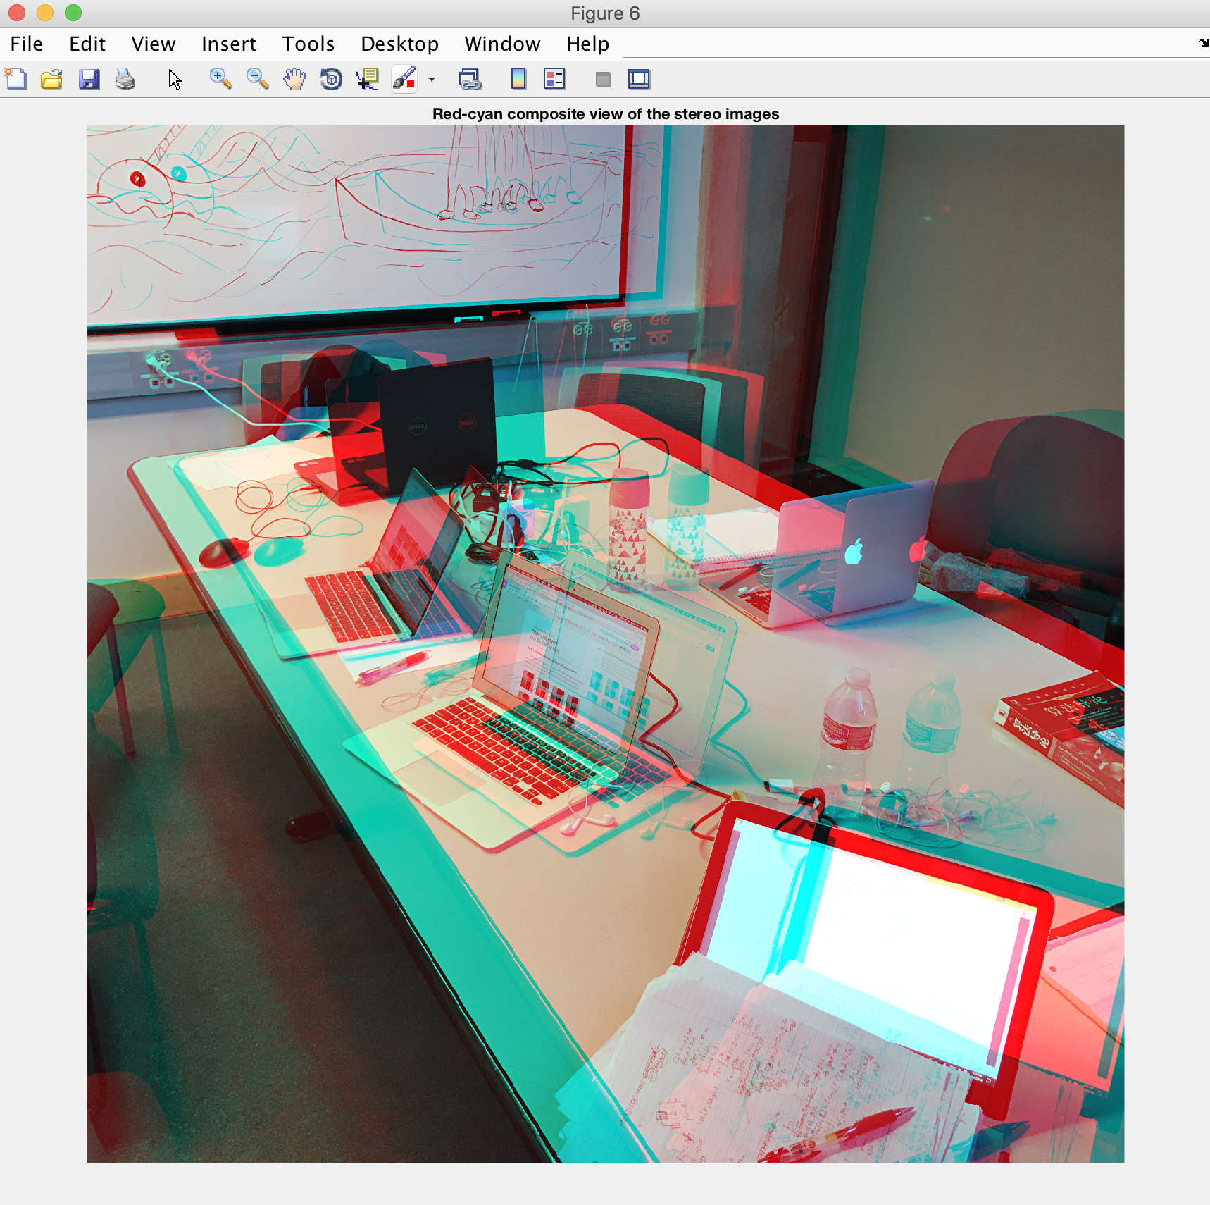

As these pictures, we can see that the items which closer from camera are showing yellow and the items far away from the camera are showing blue.

**Part 7: Plane-sweeping 3-view stereo**

We want to merge two pictures in part 6. In part6 we used disparity function in matlab to plot distance map.So we can not finish this part following instruction steps, because we cannot rotate the picture in part 5. Then we decided to use matlab to merge two images generated in part6, but the result is not as our expect.